

United Nations Development Programme
Country: Global
PROJECT DOCUMENT

Project Title: | Transforming the Global Aviation Sector: Emissions Reductions from International Aviation
UNDP Strategic Plan Outcome: | Growth and development are inclusive and sustainable, incorporating productive capacities that create employment and livelihoods for the poor and excluded
UNDP Strategic Plan Output: | Scaled up action on climate change adaptation and mitigation across sectors which is funded and implemented
Executing Entity/Implementing Partner: | International Civil Aviation Organization (ICAO)
The project will catalyze the incremental reduction of greenhouse gas (GHG) emissions arising from the implementation of additional measures that support mitigation actions for international aviation in developing States and Small Island Developing States (SIDS). The project comprises four components, namely: identification of low emissions aviation measures in developing States and SIDS; support developing States and SIDS to strengthen their national capacities and to improve their national processes and mechanisms for the reduction of aviation emissions; establishment of a technical support platform for the implementation of low emissions measures; and demonstration of low emissions aviation measures in developing States and SIDS. The fourth component of the project targets the implementation of a renewable energy pilot project involving the installation of photovoltaic (PV) panels in the airport of a SID State; thus demonstrating to developing States and SIDS the environmental and financial feasibility of replicating similar projects in their airports with minimal use of grants. The pilot project is expected to result in a direct GHG reduction benefit of approximately 17,500 tons of CO₂ during its lifecycle. Complimentary indirect mitigation benefits are expected from the strengthening of national capacities and the provision of appropriate technical assistance and guidance, for example, by clarifying the institutional, financial and technical aspects of a broad basket of emissions reduction measures. The project is expected to assist States in identifying appropriate measures and to leverage further financing towards the implementation of those measures. These complimentary indirect mitigation benefits from the four components of the project have been estimated to range from 200,000 to over 1.3 million tons of CO₂.

Programme Period: 2014-2016
Atlas Award ID: 00082348
Project ID: 00091318
PIMS # 5254
Start date: October 2014
End Date : October 2017
Management Arrangements: Agency Execution
PAC Meeting Date:

Total resources required US$ 15,000,000
Total allocated resources: US$ 15,000,000

GEF US$ 1,950,000
Other Cash US$ 9,750,000
Gov in-kind US$ 3,000,000
UNDP US$ 300,000

Cleared by: Adriana Dinu, UNDP-GEF Executive Coordinator and Director a.i.

-----------------------------------------------------------------------------------------------------------------------------------
Date/Month/Year

Agreed by (Executing Entity/Implementing Partner) :

---------------------------------------------------------------------------------------------------------------------
Date/Month/Year

Agreed by (UNDP) :

---------------------------------------------------------------------------------------------------------------------
Date/Month/Year

Table of contents 3
List of acronyms 5
- Situation Analysis 6
  - Policy Conformity 6
  - Background and Global Environmental Problem 6
  - Airports 8
  - Actions by ICAO 9
  - Action Plans 11
  - Baseline Program 11

- Project Strategy 14
  - Project Rationale 14
  - Project Objective 15
  - Project Components, Outcomes and Outputs 15
    - Component 1: Identification of low emissions aviation measures in developing States and SIDS 17
    - Component 2: Support developing States and SIDS to strengthen their national capacities and to improve their national processes and mechanisms for the reduction of aviation emissions 18
    - Component 3: Establishment of a technical support platform for the implementation of low emissions measures 19
    - Component 4: Demonstration of low emission aviation measures 19
  - GEF Incremental Reasoning 23
  - Global Environmental Benefits 23
    - Direct emissions Benefits 24
    - Indirect emissions Benefits 24
      - Indirect emissions benefits expected from Component 4 24
      - Indirect emissions benefits expected from Components 1-3 25
  - GEF eligibility 26
  - Key Risks and Assumptions 27
  - Innovativeness 32
  - Stakeholders 32
  - Sustainability (including financial sustainability) 33
  - Replicability and continuity 34

- Project Results Framework and Budget 35
  - Project Result Framework 35
  - Total Budget and Work plan (see budget note in Annex 7.7) 39
  - Summary of Funds 41

- Management Arrangements 42
- Monitoring Framework and evaluation 43
  - M&E Work plan & Budget 46

- Legal Context 47
- Annexes 48
  - Basket of measures to limit or reduce GHG emissions from international civil aviation 48
  - Endorsement Letters 52
  - Global Mean Solar Irradiance 58
  - Cost in USD per incremental KWH reduction 59
  - Methodology of direct and indirect benefits calculations 60
  - Solar PV Cost per KWH 62
  - Budget notes 63
  - Co-Financing Letter 66
  - Terms of Reference (ToRs) Solar Panels and Project Manager 68

8. Signature Page ..70

List of acronyms

ANSP Air Navigation Service Provider
APU Auxiliary Power Unit
ASBU Aviation System Block Upgrade
ATM Air Transport Management
CAEP Committee on Aviation Environmental Protection
CCM Climate Change Mitigation
CNS Communication, Navigation and Surveillance
COP Conference of the Parties to the UNFCCC
EF Emission Factor
FESG Forecasting and Economic Analysis Support Group
GEF Global Environment Facility
GHG Greenhouse Gas
GPU Ground Power Unit
GSE Ground Support Equipment
ICAO International Civil Aviation Organization
LDCs Least Developed Countries
LTO Landing and Take-off Cycle
MBM Market-based Measure
M&E Monitoring & Evaluation
PV Photovoltaic
RES Renewable Energy Sources
RPK Revenue Passenger Kilometres
RTK Revenue Tonne Kilometers
SBI Subsidiary Body for Implementation
SBSTA Subsidiary Body for Scientific and Technological Advice
SIDS Small Islands Developing States
ULD Unit Load Device
UNDP United Nations Development Programme
UNFCCC United Nations Framework Convention on Climate Change

Situation analysis

1.1 Policy conformity

The present Project “Transforming the Global Aviation Sector: Emissions Reductions from International Aviation,” supports the GEF-5 Climate Change Mitigation (CCM) Objectives 1 and 4. The project supports the GEF CCM Strategic Objective 4 (“Promote energy efficient, low carbon transport and urban systems”) as it is designed to reduce greenhouse gas (GHG) emissions from the international air transport of passengers and goods. The
trans-boundary nature of international aviation is conducive to establishing a global framework for the adoption of low GHG emission practices in international air transport through the participation of all ICAO Member States. The Project is also supports Objective #1 (“Promote the demonstration, deployment, and transfer of innovative low-carbon technologies”) since the implementation of low GHG emission measures in developing States ensures investment in, and adoption of, innovative low-carbon technologies.

1.2 Background and global environmental problem

In 2013, scheduled airlines performed a passenger traffic of 5.8 trillion revenue passenger–kilometres (+5.5% compared to 2012), totalling 3 billion of passengers, and a freight traffic of 186 billion freight tonnes-kilometres (+0.4% compared to 2012). This was achieved through a global network of more than 1,400 airlines that offer scheduled services connecting almost 3,900 commercial airports worldwide.

Based on figures from the Air Transport Action Group (ATAG), in 2012 the sector provided employment to approximately 8.7 million people globally and facilitates the movement of people, goods, and services that range from logistical links to small islands and remote communities to essential services, such as healthcare, mail, education, emergency aid and humanitarian assistance, and to data collection for scientific research and meteorology. The air transport industry contributed to 606 billion USD to global GDP and transported 35% of world trade by value and only 0.5% by volume.

Technological progress is key to achieving environmental sustainability for aviation. Aircraft are increasingly becoming more efficient, using very light composite materials, flying on sustainable alternative fuels, and research continues to seek further technological advances. In addition to this constant evolution, other new and revolutionary technologies are making their way into the market. In parallel, the need to adapt the global aviation system to climate change becomes critical to ensuring the continuity of vital air transportation links. These developments are of paramount importance given that commercial passenger and freight air traffic, as well as business aviation, are expected to continue to grow for the foreseeable future.

According to the traffic forecasts developed by ICAO:
- By the year 2030, scheduled passenger traffic around the world is expected to more than double, from 3 billion in 2013 to 6 billion annually (see Figure 1). In addition, air cargo traffic should follow a similar upward growth trend. To answer to this evolution of the demand, the number of flights should increase from 32 million in 2013 to more than 60 million in 2030 (see Figure 2).
- Between 2010 and 2040, the market share of the international traffic will grow, both for passenger and air cargo traffic.

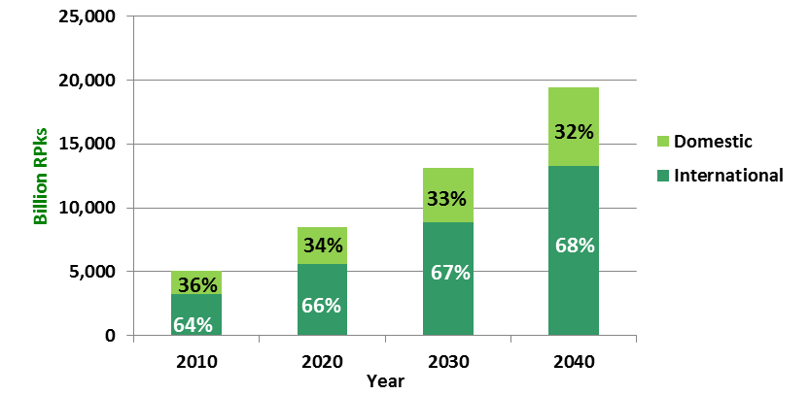
Figure 1. CAEP/9 Passenger Traffic Forecast. (source: ICAO 2013 Environmental Report)

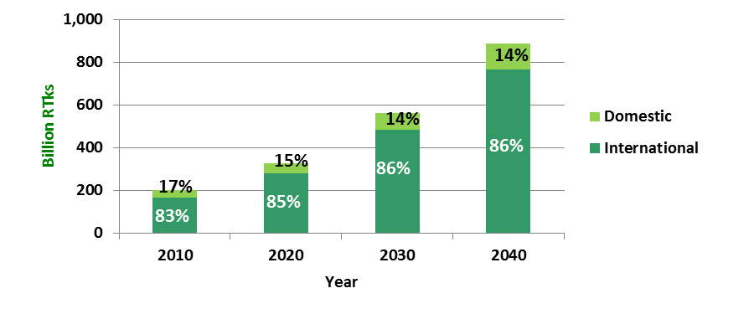
Figure 2. CAEP/9 Cargo Traffic Forecast. (source: ICAO 2013 Environmental Report)

The expected growth in aviation does not come without challenges, including the need for additional resources (financial, human, as well as natural resources), bigger aircraft fleet, increased airport and airspace capacity, better training, and more efficient air navigation systems. The aviation industry has a long history of technological innovation resulting, for example, in improved fuel efficiency of aircraft engines. Over the past 50 years, aircraft have become 80% more energy efficient and 75% quieter. Yet, technological engine innovation alone is not enough, and even with all of the technical and operational improvements expected over the forecast horizon, the environmental footprint of aviation is expected to be significant.

In 2011, commercial operators used about 271 billion litres of jet fuel and it is projected that, by 2040 fuel consumption will have increased by between 2.8 and 3.9 times the 2010 value. By extrapolating to the year 2050, it is estimated that fuel consumption will have increased four to six times the 2010 value. In 2010, CO₂ emissions from fuel consumption in aviation were 676 million tonnes accounting for approximately 2% of global anthropogenic CO₂ emissions (or 12% of transport related emissions), with international aviation producing about 60% of those emissions. For the baseline scenario, which includes fleet renewal, these emissions are projected to quadruple by 2050, but at a rate slightly slower than the aviation demand (see Figure 3).

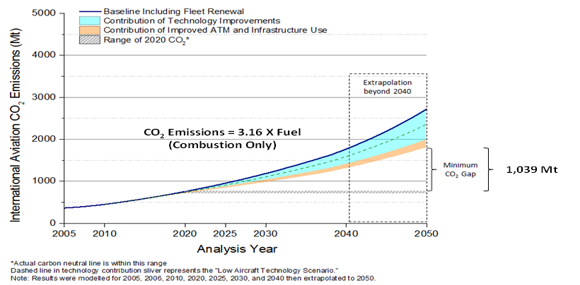

Figure 3. CO₂ Emission Trends from International Aviation, 2005 to 2050. (source: ICAO 2013 Environmental Report)

1.3 Airports

An important aspect of the aviation industry is ground operations at airports. It is evident that the expected growth in the aviation industry will lead to higher demand for airport services. Although airport operations account for a small part of the total aviation emissions, airports themselves are very important, as they are the gateways to communities, cities and countries. Undertaking emission reduction measures at airports can provide opportunities that can help towards the sustainability of the sector as a whole.

One key feature of the recent global geo-political developments is the emergence of developing States as major players in the transportation of passengers and goods. When considering airport rankings in total number of passengers in 2013, for example, eight of the world’s 20 largest airports were located in emerging markets. Traffic through Asian airports is growing continuously. In 2013, Beijing Capital Airport was the second busiest passenger airport in the world Atlanta International Airport, and Jakarta’s Soekarno-Hatta International Airport ranked 10th. In terms of cargo, also in 2013, Hong-Kong International Airport was the second largest airport in the world after Memphis International Airport, and Shanghai’s Pudong International Airport was the third one.

In 2013, Middle East was the world’s fastest growing region both in terms of passengers (11.2%) and cargo (12.0%), while Asia and Pacific was the second highest growing passenger market in the world, and Latin America and Caribbean being the third.

It is important to note that in many small States (particularly Small Island Developing States (SIDS) and least developed countries (LDCs)) the local airports almost solely service international operations, as domestic operations are either non-existent or a very small fraction of the overall airport operations. At the same time, the airports are large with sufficiently long runways to allow for the landing and take-off of large aircraft that are used for international and/or intercontinental flights, and large terminals catering to an international clientele.

1.4 Actions by ICAO

At the 38th Session of the ICAO Assembly, Member States adopted Resolution A38-18, Consolidated statement on continuing ICAO policies and practices related to environmental protection – Climate change, which reinforced their collective determination to continue their work on protecting the global climate. ICAO’s Member States made it unequivocally clear that the air transport sector is committed to meeting its responsibilities for sustainable development, maximizing its support for economic development, reducing its impact on the environment, and consolidating its social benefits. The provisions of A38-18 are based on those from the landmark agreement (Resolution A37-19) reached at the 37th Session of the ICAO Assembly in September 2010 that established short, medium and long term aspirational goals for the sector.

The Assembly agreed to:
- an annual 2% fuel efficiency improvement until 2020, with a further global aspirational goal of 2% efficiency improvement from 2020 to 2050;
- to achieve a collective medium term global aspirational goal of keeping the global net carbon emissions from international aviation from 2020 at the same level, which would result in an emissions growth path peaking in 2020;
- explore the feasibility of a long term global aspirational goal for international aviation.

The ICAO Assembly has also recognized that despite increased efficiency, the current growth trends of international air traffic outweigh the gains made by fuel efficiency improvements, and, therefore, there is a need for further emission reduction measures. To help achieve the aspirational goals set in Resolution A38-18, the ICAO Assembly identified a basket of measures (from which States could choose), which includes the following (for more details see Annex 7.1):

- Aircraft related technology development: ICAO is currently developing a global CO₂ certification Standard for aircraft. Short and medium-term measures include purchase of new aircraft, retrofits and upgrade improvements on existing aircraft, as well as optimizing improvements in aircraft produced in the near to mid-term, while longer-term measures include the adoption of revolutionary new designs in aircraft/engines and the setting of more ambitious Standards.

- Alternative fuels: The use of alternative fuels may lead to significant emissions reductions. However, their production requires substantial investments by producers and possibly distributors. Incentives and support would be needed to facilitate the implementation of such measures. Benefits will depend on the availability of such fuels, their lifecycle emissions reduction and the time profile of their introduction.
- Improved air traffic management and infrastructure use: Improved use of communication, navigation and surveillance/air transport management (CNS/ATM) can improve the efficiency of air traffic management, leading to reduction in fuel burn and emissions. Problems associated with the provision of efficient air navigation services relate, among other things, to airspace fragmentation and lack of homogeneity, inefficient routing and ATM planning leading to possible congestion with related fuel burn penalties. Environmental benefits can be derived from more efficient air traffic management, ground operations, terminal operations (departure, approach and arrival), en-route operations, airspace design and usage, aircraft equipment and capabilities.

- More efficient operations: Emissions reduction may be achieved in the short-term with minimum investment through improved aircraft operations and management. Improvements can be introduced in pre-flight procedures (centre of gravity, take-off weight, flight planning, taxiing, APU) as well as in-flight procedures (take-off and climb, cruise, descent, holding and approach) and post-flight maintenance procedures (airframe and engine maintenance and aerodynamic deterioration).

- Economic/market based measures: Market-based measures (MBMs) are policy tools designed to achieve environmental goals at a lower cost and in a more flexible manner than traditional regulatory measures. ICAO has been developing policies and guidance material, as well as collecting information on various MBMs, including emissions trading, emission-related levies (charges and taxes), and emissions offsetting.

- Regulatory measures/other: Includes airport movement caps/slot management; enhancing weather forecasting services; requiring transparent carbon reporting, conferences/workshops.

- Airport improvements: Includes airfield improvements, reduced energy demand and use of renewable energy sources, enhanced Ground Support Equipment (GSE) management, conversion of GSE to cleaner fuels, improved transportation to and from airport. Airport infrastructure measures related to reducing aircraft emissions at airports include measures such as improving the efficient use and planning of airport capacities, the installation and use of terminal support to reduce aircraft Auxiliary Power Unit (APU) usage and the construction of additional taxiways and runways to provide direct terminal access and reduce congestion.

Studies undertaken by ICAO have shown that all elements of the basket of measures will be needed in order for international aviation to reach carbon neutral growth after 2020. The measures selected by ICAO Member States to contribute toward the achievement of the global aspirational goals are communicated to ICAO through their action plans on CO₂ emissions reductions activities.

The ICAO Assembly also requested the ICAO Council to study, identify and develop processes and mechanisms to facilitate the provision of technical and financial assistance, as well as financial access to existing and new financial resources, technology transfer and capacity building to ICAO Member States.

Through the increased use of low-carbon technology, environmentally sustainable materials, new aircraft systems, efficient operations and sustainable energy sources, the air transport sector is making significant advances across a range of sustainability issues. It does so by making sure that its actions around the world are based on the economic, environmental, and social pillars of sustainable development.

1.5 Action plans

The ICAO Assembly, through Resolution A37-19, encouraged ICAO States to submit action plans, which are a planning and reporting tool for States to communicate information on their activities and plans to address CO₂ emissions from international civil aviation. The information contained in an action plan will ultimately enable ICAO to compile global progress towards meeting the goals set by Assembly Resolution A37-19. In addition, action plans give States the ability to: establish partnerships; promote cooperation and capacity building; facilitate technology transfer; and obtain assistance.

A key aspect of successfully developing and implementing an action plan is the degree and nature of collaboration among different stakeholders within a State. These can include aviation and environmental authorities, airlines and airports, air navigation service providers (ANSPs), statistical departments and fuel providers. Collecting information from these stakeholders and consolidating this input into an action plan ensures that the development of the plan is based on a cooperative process and that the measures contained therein are accurate, comprehensive, and feasible to implement.

ICAO has an ongoing program that provides technical guidance to its Member States to reduce CO₂ emissions from international civil aviation. Furthermore, ICAO has developed, in collaboration with an ad-hoc group of experts from the CAEP composed of States and stakeholders, ICAO Doc 9988, Guidance on the Development of States’ Action Plans on Emission Reduction, which serves to guide States, step-by step, through the process of preparing and submitting an action plan for emission reductions from international aviation.

A dedicated interactive web interface was also developed to facilitate the submission of States’ action plans to ICAO. The action plan development process establishes a framework to enable ICAO States to undertake the necessary steps in identifying assistance, capacity building and implementation measures to contribute to the achievement of the aspirational goals of ICAO. The information incorporated in action plans includes estimated CO₂ emissions from international aviation and identification of specific mitigation measures (selected from the basket of measures) that could be implemented to reduce the impact of international aviation on the global climate.

As of mid-August 2013, 63 ICAO States, accounting for about 80% of the global international traffic, have submitted action plans to ICAO (out of the 63 States, 25 have been submitted by GEF eligible countries). Fifteen States have initiated the development of an action plan, while the remaining have not yet begun the process.

Several ICAO States provided information regarding their emissions levels as well as their plans to implement actions to reduce these emissions. From an analysis of the reported information, the categories “Aircraft technology”, “Alternative fuels” and “Improved air traffic management and infrastructure use” are those most commonly identified in the submitted action plans.

1.6 Baseline program

The baseline program consists of ongoing and forthcoming activities that arise from elements associated with the action plans and implementation of mitigation measures already considered and supported by ICAO.

For some ICAO Member States, in particular developing States, the preparation of action plans and the implementation of specific mitigation actions depend on the availability of assistance and financing. Since the adoption of Resolution A37-19 in 2010, ICAO has developed and is implementing a robust capacity building programme to assist States with the preparation and submission of action plans.
The programme components include:

- Development of a detailed guidance manual for the development of action plans;
- Development of a web interface for action plans;
- Convening hands-on regional training seminars for action plans, covering all ICAO regions;
- Provision of assistance through conference calls, to identify and respond to specific requests from States;
- Development of appropriate tools such as the ICAO Fuel Savings Estimation Tool (IFSET) and the ICAO Carbon Emissions Calculator;
- Assistance to various ANSPs in quantifying emissions reductions accrued through navigational measures;
- Development of various information sharing web-based portals, including the ICAO Global Framework on Aviation Alternative Fuels (GFAAF);
- Publication of special editions of the ICAO Journal and ICAO Environmental Report covering the latest developments and technical issues related to aviation and the environment;
- Convening ICAO events (e.g. seminars, symposia), to facilitate information sharing and to initiate discussion with ICAO Member States and other stakeholders on key areas related to aviation and the environment.

The events organized by ICAO provided States and other stakeholders with essential information on a range of assistance initiatives, including: capacity building; new technologies; financing for emissions reduction activities; technology transfer; and technical support. In particular, they highlighted the synergies and constructive engagement among ICAO, its Member States, stakeholders, and other international organizations during the first phase of the initiatives related to the action plans.

ICAO, through its various programmes, has a long tradition of providing technical assistance and guidance to States that may not have the necessary knowledge and capacity to implement aviation-related actions in areas such as safety measures, air traffic management improvements, technical training etc. Of note is the assistance programme currently underway by the ICAO Technical Cooperation Bureau (TCB), which involves offering technical support to States to develop and implement their action plans under the “Strategic Plan for the Provision of Assistance for States’ Action Plans”. This cooperation is reinforcing the wide-ranging series of concrete programmes and measures that ICAO has been pursuing to help its Member States mitigate their international aviation CO₂ emissions.

An example of this assistance programme is a large-scale environmental project currently underway to implement the measures identified in the Indonesian action plan, involving the government of Indonesia and ICAO–TCB. This initiative reflects the determination of Indonesia to meaningfully address the environmental performance of its air transport sector, over both the near- and long-term, while also supporting national regulations, in particular recent presidential decrees on GHG emissions. ICAO –TCB is working on the new project directly with the Directorate General of Civil Aviation of Indonesia. The agreed objectives include a master plan for legislative improvements on emissions, including the Green Flights and Green Airports operational programmes, more efficient airspace design utilizing performance-based navigation guidelines, advice on appropriate market-based measures, as well as initiatives relating to alternative fuels and the development of a comprehensive aviation emissions inventory[1].

In addition, ICAO has established partnerships with the European Commission (EC) as part of its efforts to provide further assistance to States and facilitate access to financing for the development and implementation of action plans. Following the signatures by the ICAO Secretary General and representatives from the EC on 17 December 2013, of ICAO’s joint project “Capacity Building for CO₂ Mitigation from International Aviation”, 14 States from the African and Caribbean regions have been selected. This project aims to reinforce/develop capacity building for CO₂ mitigation from international aviation and provide support to these States to develop their action plans, including the development and implementation of an aviation environmental system and measures to reduce aviation fuel consumption. The estimated duration of the project is 42 months.

Limitations of the baseline program

Over the last three years, ICAO has made significant efforts to train national experts (focal points) on action plans, for example, through regional workshops and by providing in-country assistance, as well as by developing and widely disseminating guidance materials (development of detailed guidance document, development of online and calculation tools etc.). Despite these efforts and encouraging response from States:
- Not all ICAO States have been able to submit an initial action plan. Out of the 191 ICAO States, 63 of them prepared and submitted an action plan (this represents a response of about 33%). It is noted that out of these 63 States, 25 are from GEF eligible countries;
- Fifteen other ICAO States have initiated the development of an action plan, while the remaining have not yet begun the process;
- An analysis of the 63 submitted action plans revealed that approximately two thirds of them are, to a degree, incomplete;
- Some action plans lack the data needed to make a reliable assessment of States’ CO₂ emissions reduction potential, while others do not provide enough information on national baselines or identified mitigation measures.

The development of sound action plans, including the identification of potential measures, is particularly challenging for developing States and SIDS. These States are usually constrained by lack of financial resources and technical expertise needed to identify and implement mitigation measures. It is emphasized that based on the ICAO air traffic forecasts for the coming decades many developing States, including SIDS, will experience a growth in traffic. This makes them ideal candidates for the implementation of mitigation measures that could result in significant reductions (compared to a business-as-usual scenario) in GHG emissions.

Continuing with the implementation of such existing activities alone is unlikely to result in significant improvements in the rate of development and implementation of action plans. Thus far, the ICAO activities have concentrated on assisting ICAO States to compile their action plans in response to the mandate from the ICAO Assembly. Although these activities will continue as part of ICAO’s remit, it is imperative that new parallel initiatives begin in order to provide assistance on how the mitigation activities included in the action plans can be implemented in developing States and SIDS. Under the baseline program, the actual implementation of aviation-related measures was left up to individual ICAO States following capacity and training activities. The complexity of addressing climate change while ensuring the sustainable development of international aviation is a new area for the vast majority of developing States and poses a number of challenges that require improvements in the level of assistance and support provided.

Figure 4 illustrates the baseline activities and those under the four components of this project, which are expected to provide incremental benefits.

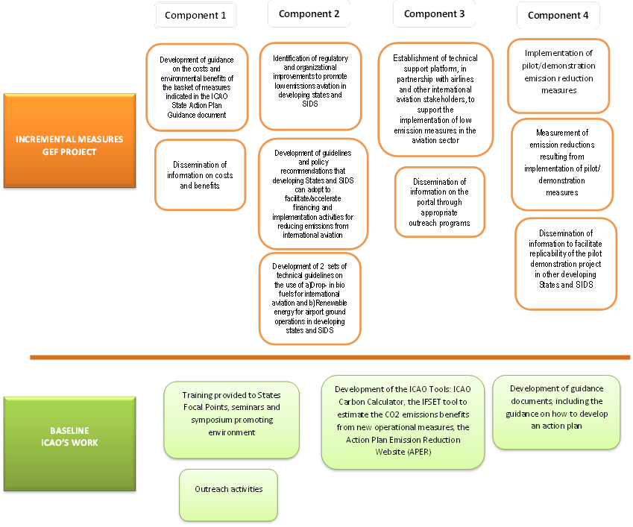
Figure 4. Baseline activities and incremental measures under the four components of this project.

Strategy

2.1 Project rationale

As presented in section 1, ICAO forecasts a significant growth in air traffic on a global scale for the coming decades. A large part of this growth is expected to happen in developing States and SIDS, some of which are already emerging as key players in the international transportation of passengers and goods.

Given the agreement within ICAO for global action to achieve aspirational goals (without any national allocation of responsibility), all ICAO States would be contributing in the effort towards a sustainable future for the aviation sector, taking into account their national capacities and capabilities.

As explained in section 1.6, Baseline program, ICAO will continue its efforts to assist its Member States to implement the provisions of the ICAO Assembly resolutions on international aviation and climate change (A38-18 and A37-19). ICAO will accomplish this as part of its ongoing work programme including by assisting States to develop high quality action plans, identify nationally-appropriate mitigation activities for international aviation and promote the involvement of all relevant stakeholders, who will take ownership of the measures’ implementation. This will ensure that the action plans are not a theoretical exercise but can provide the basis on which developing States and SIDS engage in the global efforts that will have a transformational effect on international aviation.

In relation to this project, ICAO is proposing additional activities that do not form part of the current work programme of the Organization. The focus of these activities will be assisting developing States and SIDS. The aim of these activities is two-fold:
- To foster nationally-appropriate actions on international aviation in developing States and SIDS where no such action would have been taken; and
- To accelerate the rate of implementation by assisting States to overcome barriers through the implementation of specific mitigation actions.

The Project Strategy is presented as a logical framework approach. The essence of this approach is that outputs are clustered by outcomes, which together will achieve the project objective. These are described in sections 2.2 and 2.3.

2.2 Project objective

The objective of the project is to support capacity building in developing States for implementing technical and operational measures for reducing CO₂ emissions from international aviation.

Achieving a sector wide transformation toward a low carbon aviation industry requires concerted action at the global and national levels. While technical innovation is clearly necessary for improved efficiency, a global transformation to a low emissions aviation industry that fully accounts for developing States must also include technical support, strengthening of national capacities, and the creation of a policy and market environment that rewards investment in low emission technologies. The UNDP/ICAO partnership, supported with GEF resources, will establish a framework that allows the international aviation sector in developing States and SIDS to fully engage in low emissions aviation and fulfil their GHG emissions reduction potential. This will be accomplished through the implementation of four project components, designed to stimulate the implementation of low emission aviation measures in developing States and SIDS.

2.3 Project components, outcomes and outputs

The project comprises four components:
- Identification of low emissions aviation measures in developing States and SIDS;
- Supporting developing States and SIDS to strengthen their national capacities and improve their national processes and mechanisms for the reduction of aviation emissions;
- Establishment of a technical support platform for the implementation of low emissions measures;
- Demonstration of low emissions aviation measures in developing States and SIDS.

Each component includes specific outcomes and outputs which are interrelated, as shown in more detail in Figure 5.

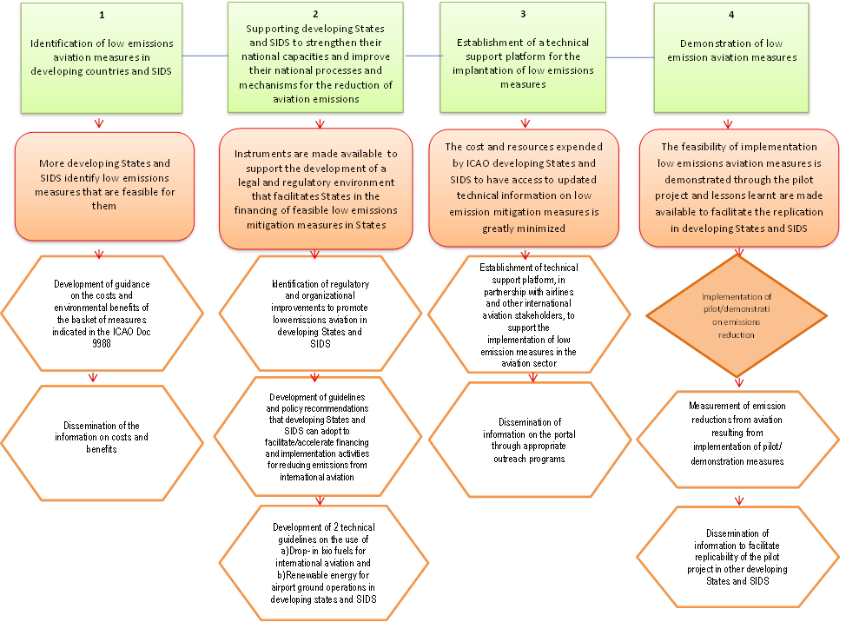
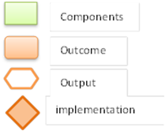

Figure 5. Schematic of the four project components and their specific outcomes and outputs.

Note 1: As depicted in in Figure 5, there are three project outputs related to the dissemination of information, in particular: under Component 1 (dissemination of information on costs and benefits); under Component 3 (dissemination of information on the portal); and under Component 4 (dissemination of information on the pilot project). To avoid proliferation of workshops and to ensure efficiency, it is proposed to organize two workshops funded by GEF in regions with SIDS (one in the Caribbean region and one on the Pacific region) that will be used to disseminate the information from all three components. States in other regions will engage in this project during other regularly scheduled ICAO events, in which space for project-specific activities will be included.

Each of the components is described in more details below.

2.3.1 Component 1: Identification of low emissions aviation measures in developing States and SIDS

Outcome 1: More Developing States and SIDS identify low emissions measures that are feasible for them
Through this component, ICAO will provide technical support and guidance to developing States and SIDS in order to enable them to identify feasible low emissions measures and report them to ICAO through the State action plan process. The proposed outputs (1.1 and 1.2) are additional to the mandated and planned ICAO activities described earlier (e.g., outreach activities relating to the dissemination of State action plan guidance contained in Doc 9988). One of the main difficulties of developing States and SIDS is the lack of information and guidance on the costs and environmental benefits associated with the basket of measures contained in ICAO Doc 9988, Guidance on the Development of States’ Action Plans on Emission Reduction.

This guidance on costs and environmental benefits will address this difficulty by allowing/facilitating developing States and SIDS to make informed decisions regarding implementing mitigation actions that are most feasible in light of their national circumstances. This component is also expected to result in an increase in the number of action plans submitted to ICAO. Furthermore, it is expected that the information submitted will be more complete and comparable across States enabling ICAO to improve its assessment of the progress towards meeting the overall aspirational goals, as stated in Resolution A38-18.

Output 1.1: Development of guidance on the costs and environmental benefits of the basket of measures indicated in ICAO Doc 9988.
ICAO will conduct a detailed assessment of the costs and environmental benefits associated with implementing various feasible measures in developing States and SIDS, including renewable energy projects. The assessment will take into consideration the most recent and up-to-date studies and reports on economic costs, financial implications and benefits of aviation measures published by, inter alia, relevant national authorities, regional and international organizations, industry associations, academia, and non-governmental organizations. The results of the assessment will be presented in a report including guidance for developing States and SIDS on how to identify and implement measures that are appropriate to their national circumstances.

Output 1.2: Dissemination of the information on costs and benefits
Following the completion of the assessment study under Output 1.1, ICAO will disseminate the results to ICAO Member States. Two workshops will be organized in the context of this project, specifically targeted to SIDS. During the workshops, ICAO will inform national experts of the results of the assessment, in particular the costs and benefits of different mitigation actions, and assist them to use this information to select amongst different mitigation options. ICAO Member States in other regions will engage with the project during other regularly scheduled ICAO events, which are co-financed by ICAO.

2.3.2 Component 2: Supporting developing States and SIDS to strengthen their national capacities and to improve their national processes and mechanisms for the reduction of aviation emissions

Outcome 2: Instruments are available to support the development of a legal and regulatory environment that facilitates the financing of feasible low emissions aviation measures in States
Through this component, ICAO will develop guidance and recommendations that are essential to stimulate the willingness and financing for implementing low emissions reduction measures. Such guidance and recommendations are not currently available for ICAO developing States and SIDS and it is expected that they will support the strengthening of national capacities leading to incremental actions that will bring about reductions in emissions from international aviation.

Output 2.1: Identification of regulatory and organizational improvements to promote low emissions aviation in developing States and SIDS
ICAO will develop guidance for developing States and SIDS on how to identify nationally appropriate improvements in regulations and organizational structures to help them implement low emissions strategies and measures in the aviation sector. This will include guidance on how to:
- Draft recommended national legislation and/or develop specific legal instruments (e.g. laws, memoranda of understanding, etc).
- Establish national teams that would identify appropriate mitigation measures and oversee the process for their implementation.

Output 2.2: Development of guidelines and policy recommendations that developing States and SIDS can adopt to facilitate/accelerate financing and implementation activities for reducing emissions from international aviation
Building upon CAEP support documents, ICAO will develop guidelines and policy recommendations specifically targeted to developing States and SIDS, particularly:
- Guidelines on how to secure financing from various available sources (public, development finance institutions (DFI) and private) best suited for developing States and SIDS including self-financing of projects wherever feasible.
- Guidelines on self-financing strategies that can be used by various stakeholders in developing States and SIDS in implementing emissions reduction projects.
- Guidelines and policy recommendations in the area of renewable energy projects, including best practices on how to deal with public utilities and private renewable energy providers (e.g. feed-in tariffs, power purchase agreements, land lease agreements, and ownership models for environmental projects in airports).

Output 2.3: Development of two technical guidelines on the use of: a) Drop-in bio fuels for international aviation; and b) Renewable energy for airport ground operations in developing States and SIDS.
Over the last years, there has been growing interest in the use of renewable energy for aviation, especially because of its significant emissions reduction potential. The efforts of ICAO States have focused on two key areas: drop-in biofuels and use of renewable energy (RE) at airports. Within the aviation community, however, there is a lack of guidance on the use of RE for the sector. Therefore, ICAO will develop two technical guidance documents, providing appropriate assessments and guidelines to developing States and SIDS, in relation to:
- The incorporation of drop-in biofuels for international aviation
- The feasibility of using RE at airports

The guidance on drop-in biofuels will build on the outcome of the GEF targeted project “Global Assessments and Guidelines for Sustainable Liquid Biofuel Production in Developing Countries”, but will focus on the specific circumstances of the international aviation taking into consideration particular challenges and opportunities. For the latter, ICAO will use relevant up-to-date information on the utilization of RE, including (but not limited to) the IPCC Special Report on Renewable Energy Sources and Climate Change Mitigation, as well as the IPCC Fifth Assessment Report.

2.3.3 Component 3: Establishment of a technical support platform for the implementation of low emissions measures

Outcome 3: The cost and resources expended by ICAO developing States and SIDS to have access to updated technical information on low emission mitigation measures is greatly minimized
Under this Component, ICAO will support developing States and SIDS in their implementation of low emissions measures through the establishment of an integrated environmental portal to share relevant information from a range of stakeholders. The integrated portal will also facilitate ICAO’s provision of assistance leading to an accelerated implementation of environmental ICAO standards, practices, guidelines and recommendations.

Output 3.1: Establishment of a technical support platform, in partnership with airlines and other international aviation stakeholders, to support the implementation of low emission measures in the aviation sector.
The technical platform will bring together all technical information essential to implement emissions reduction measures such as standards, tools, guidance documents, guidelines, information on indicative costs, benefits, training material, in a SharePoint-like portal accessible from anywhere by States. The information will be public domain and will be collected from different sources including: ICAO, national governments, academia, vendors, business associations, etc. The availability of such a platform will also significantly reduce the time spent, costs and other overheads of developing States to collate information, leading to incremental implementation of emissions reduction measures.

Output 3.2: Dissemination of information on the portal through appropriate outreach programs.
During the two workshops that will be organized in the context of this project, ICAO will provide hands-on training and support to SIDS on the use of the portal and other tools. In addition, ICAO will use the portal to communicate with, and provide further ad-hoc assistance to, developing States and SIDS in the implementation of measures identified in their action plans. These outreach activities are expected to enhance the implementation of mitigation activities in developing States and SIDS. ICAO Member States in other regions will be provided with information from this project during other regularly scheduled ICAO events.

2.3.4 Component 4: Demonstration of low emissions aviation measures

Outcome 4: The feasibility of implementing low emissions aviation measures is demonstrated through the pilot project and lessons learnt are made available to facilitate replication in developing States.
ICAO has identified the installation of photovoltaic (PV) panels at the international airport of Jamaica as an ideal candidate for the pilot project. Specifically:
- The choice of an implementation measure in an airport was preferred as it does not implicate competitive distortions that would have been the case if a measure was implemented for one air carrier to the detriment of another carrier operating in the same area.

- Jamaica is a SIDS that fulfils the following criteria that were defined for this project:
- Consistent with the UN initiative designating 2014 as the International Year of SIDS
- Capacity exists for installation in busy international airports of SIDS
- Large international airport and tourism are major contributors to the national economy
- Proximity to ICAO Regional Offices
- Support letters received from CASSOS which represents all 7 SIDS in the Caribbean, the Government of Jamaica, the Government of Kenya, and the Government of Japan (See Annex 7.2)
- Received letter of intent from the Chairman of the Civil Aviation Authority confirming that the Government of Jamaica grants land for the pilot project.

- A preliminary assessment by ICAO indicates that for the purpose of the project demonstration in Jamaica, the installation of PV panels would be an ideal measure to implement for the following reasons:
- Abundance of solar energy (see Annex 7.3).
- Experiences learnt from airports that have already installed solar panels.
- Its cost effectiveness (incremental emissions reduction per $ spent) as indicated in Annex 7.4 compared to other measures leads to increasing replicability and facilitating financing.
- Access to open landscape (as one of the requirements for the installation of PV panels).
- Good proximity to electricity sub stations or electricity distribution points.

During the project implementation, the lessons learnt from the pilot project for each milestone phase will be closely monitored and well documented. These phases will cover activities pre and post implementation, as well as the measures adopted to quantify the emissions reduction benefits. The documentation of the lessons learnt from the pilot project will be the basis for outreach and communicating the project to other developing States and SIDS.

Output 4.1: Implementation of pilot/demonstration emission reduction measures
A promising mitigation activity that involves the reduction of international aviation fuel is limiting the use of on-board APUs. APUs are used to provide electricity to, and run the air conditioning of, an aircraft after it has landed or while it is readied for take-off. According to industry data, APUs consume anything from 40 gallons of jet fuel per hour to more than twice this amount depending on the size and operating conditions of an APU. It is clear therefore that there is a significant potential to reduce CO₂ emissions by eliminating the use of APU while an aircraft is on the ground.
An alternative to APUs is the use of ground support equipment, such as GPUs, which can provide the required electricity to an aircraft while running on liquid fossil fuels (e.g., diesel oil) or grid electricity. The proposed pilot project involves the installation of PV panels to produce electricity that will be used to run GPUs replacing APUs for international flights.
The benefits of replacing grid electricity at airports are associated with reducing international aviation fuel consumption for APUs and improving airport operations. For this project, it is expected that the airport electrical system will be powered by both solar power and grid power. All the solar power will be fed into the airport’s electrical system. To avoid complexities associated with feeding the solar power into the national grid (e.g. negotiating a power purchase agreement), it is proposed that the solar power produced will be consumed on site. When the PV array is producing less than the airport needs, the utility will compensate. With a large enough solar panel system, the amount of energy produced by the solar panel system per year could offset the amount of energy used from the grid. The diagram below illustrates this option. In the unmitigated case, the airport produces its own electricity or purchases electricity from the national grid, the majority of which comes from the combustion of fossil fuels.

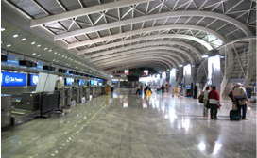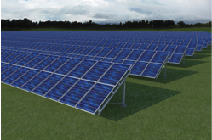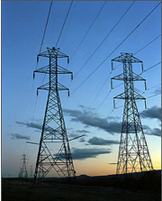
Airport electrical system

Table 1 is an indication of the optimal energy reduction potential from installing solar panels in a single airport using a unit of 1 acre (4,000 sq. meters).
Table 1: Factors to consider for solar panel project implementation in airports.
FACTORS TO CONSIDER FOR SOLAR PANEL PROJECT IMPLEMENTATION IN AIRPORTS
PARAMETERS | Max Range
Area | 1 acre
Module Tilt | 30 degrees
Number of 60 cell solar panels | 1,560
Panel Wattage (W) | 255
System Size DC (Kw) | 398
PRODUCTION NUMBERS
Annual hours of energy generation | 2,000
Energy Generated kWh/year | 795,600
ESTIMATED COSTS
Ground Mount System (US $/W) | 2.80
Turnkey Cost | $1 million
Operations & Maintenance (US $/year) | $5,000
REVENUE POTENTIAL
Avoided Cost (US$/kWh) | $ 0.10 to $ 0.20
Annual Potential Savings | $ 79,560 to $ 159,120
LYFECYCLES
Years of useful life | 25

The above numbers are generic averages and could vary depending on the specific local conditions prevailing on the project site.
A 1 acre (4,000 sq. meters) ground installation could thus reduce energy consumption on board of aircraft by around 800,000 kWh each year. This translates to an estimated CO₂ emissions reduction of around 700,000 kg each year, (this is based on the use of an EF of about 0.88 kg CO₂/kWh for Jamaica), which over the lifecycle (25 years) of the project could thus reduce emissions by at least 17,500 metric tons. As can be seen from the example of a 1 acre installation, the project could have a pay back in around 8 to 16 years, besides providing the convenience of ensuring a fixed power tariff to the airport utility. The methodology used to arrive at this estimate is detailed in Annex 7.5.

Taking a conservative approach and assuming that a GPU of 180 kW will operate for one (1) hour, while an aircraft is on the ground, and using the data in the Table 1 (PV panels yielding a total of 795,600 kWh per year) it is estimated that the installed PV panels can provide electricity for 4,420 flights per year.

The solar power, that will be fed into the airport electrical system thus reducing the requirements of consuming fossil based electricity from the grid, will be allocated to the international aircraft operating out of the selected airport(s) based on the number of aircraft movements and average GPU’s usage for each aircraft.

Output 4.2: Measurement of emission reductions from aviation resulting from implementation of
pilot/demonstration measures.
As part of the preparatory phase for the pilot project, information will be collected on the usage of APUs, by specific aircraft type and the related consumption of aviation fuel while aircrafts are on the ground. This information will be used to estimate the potential reduction of aviation fuel as result of the pilot project. As part of the implementation of the pilot project, a meter will be installed to measure the amount of electricity produced by the PV panels.

It will be assumed that the amount of electricity produced by the PV panels will replace an equivalent amount of grid electricity. Additional information will be collected on the electricity generation system in Jamaica (e.g. amount of electricity produced, technology used, mitigation measures (if any), fuels used and their characteristics, distribution losses, etc.). Based on this information, an average grid EF (EF_{Grid}) will be developed that represents the average amount of CO₂ released per kWh produced by the grid. The quantity of CO₂ avoided because of the pilot project will be calculated by combining the PV electricity production and the EF through the following equation:

Emissions_{avoided} = kWh of PV electricity provided to airport building • EF_{Grid}

Output 4.3: Dissemination of information to facilitate replicability of the pilot project in other developing States and SIDS.
In the context of the workshops to be organized under this project, ICAO will communicate the lessons learnt from the pilot project implementation during its different phases and will develop a roster of States where the pilot project can be scaled up in the future. The outreach of ICAO, in collaboration with other stakeholders, will assist developing States and SIDS to better understand the technical and financial feasibility of replicating similar projects, leading to further incremental emissions reductions. States in other regions will engage in this project during other regularly scheduled ICAO events co-financed by ICAO.

2.4 GEF incremental reasoning

The commitment of ICAO Member States and of the aviation industry to implement a strategy for environmentally sustainable growth forms a strong basis for the GEF project. Furthermore, the roadmap established by ICAO is a solid foundation for action. However, to date there are noticeable differences in the level of engagement among ICAO Member States. The submission status of action plans mirrors these differences, as a large majority of those were submitted from developed States and some large developing States. There is a risk that, without additional support and encouragement, this gap will widen and developing States will fall significantly behind in the development and implementation of low emission programmes for international aviation. As a global sector in which the majority of growth is expected to occur in developing States, it is essential for all States to fully engage in reducing GHG emissions in order to meet ICAO’s global aspirational goals.

The GEF project is designed to support GEF-eligible ICAO Member States in engaging further in low emissions aviation planning and implementation. Several developing States require financial and technical support to implement the measures outlined in their action plans. The incremental adoption of technical guidance and activities faces constraints of financial feasibility, since many measures bring about CO₂ reductions at costs of capital that could be used elsewhere in the business cycle with better returns. This is of concern, especially to developing States that are already constrained due to lack of access to capital and/or high borrowing costs. Financing from GEF and
co-financing from other entities will reduce this constraint by reducing the cost of adopting new technologies by developing States that otherwise could not have been implemented. Likewise, there are significant technical and capacity constraints in developing States that prevent the adoption of aviation regulations and procedures that can significantly reduce CO₂ emissions.

The principal added value of this project is that it will allow for the enhanced involvement of developing States in reducing emissions from international aviation. By providing strengthened technical assistance, guidance and capacity building to developing States, the project will ensure that such States are able not only to develop high quality action plans, but to make informed choices in selecting and implementing appropriate mitigation measures to reduce GHG emissions from international aviation. Through the demonstration of feasible low emission measures, the project will encourage technology transfer and knowledge sharing, leading to a more rapid adoption of state-of-the-art technology. The project is timely, as ensuring more active engagement by developing States and SIDS at this time will allow them to build in low emission measures into their long term planning and investment strategies, as they prepare to experience high growth rates in the sector.

2.5 Global Environmental Benefits

The global environmental benefits of the Project will be both direct and indirect.

The direct emissions benefits will be the emissions reductions from the pilot project (Component 4) and the indirect emissions reduction are expected from:

a) The replicability of the pilot project in the airports of other developing States and SIDS; and
b) The strengthening of national capacities and the provision of technical assistance and guidance in this project (Components 1-3).

These emissions benefits are explained in detail in paragraphs 2.5.1 and 2.5.2.
2.5.1 Direct Emissions Benefits
The direct benefits are the emissions reductions from adopting renewable solar energy to replace fossil energy for electricity generation wholly attributable to the Pilot Project in the SIDs. The direct emissions reduction benefits from implementing the pilot project is explained under Output 4.1 and in Table 1. The installation of at least 1 MW of new decentralized RE power generation capacity during the lifetime of the project (25 years) is expected to facilitate in the direct CO₂ reduction benefit of approximately 17,500 tons of CO₂.

2.5.2 Indirect emissions benefits
2.5.2.1 Indirect emissions benefits expected from Component 4
The project will facilitate increased use of RE and decreased use of fossil based energy sources in airport installations. The successful implementation of the pilot project as indicated in Component 4 will facilitate or drive available co-financing in RE projects in developing States and SIDS. Developing States will be made aware of the self-financing potential or minimal grant needed to fund and implement the project as demonstrated in the pilot project. The project is also expected to promote private sector vendor participation and innovative funding options that will hasten the implementation of RE projects in developing States.

Recognizing the potential from RE solutions and its cost effectiveness, there is a significant potential for airports in the developing world to adopt such a solution. Preliminary estimates using available data with ICAO and ACI and our coordination with stakeholders suggest that the potential emissions reduction from this RE adopted by airports are large. Table 2 indicates the range of the global solar RE potential that exists worldwide in utilizing estimated free land area in the airports of developing States.

Table 2: Indirect emission benefits potential in international airports of developing States and SIDS representing at least 1% of emissions in their region from replicating the pilot project (Component 4).

Region | Total Airports
(a) | (b)
Africa | 20
Asia | 55
Middle East | 26
South America | 39
Central America | 43
SID | 26
Total | 209

Table 3: Range of annual indirect emissions reduction benefits from replication of the pilot project in bands of 5% in the ~200 international airports of developing States and SIDS.

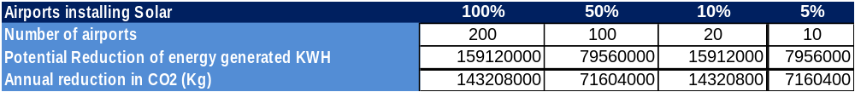

A conservative estimate, wherein between only 10 to 20 airports in developing States and SIDS replicate the pilot project, will result in indirect emissions reduction benefits ranging from 180,000 to 360,000 tons of CO₂ during the lifetime of the project. The methodology is indicated in Annex 7.5 of this document.

In addition, it will also provide multiple benefits in terms of creating employment opportunities in the developing States and other social benefits.
2.5.2.2 Indirect emissions benefits expected from Components 1-3
The Outputs indicated in Components 1 to 3 are expected to generate significant indirect emissions reductions in developing States. Under the baseline scenario there is currently a lack of appropriate updated guidance and recommendations that will assist developing States in identifying measures that could be implemented with their cost and pay back implications. This is expected to be addressed by this project under Output 1.1 (Component 1). The provision of technical and financial guidance on implementing cost effective measures, as well as recommendations on organizational structure and regulatory improvement under Components 2 and 3, is expected to strengthen national capacities of developing States and SIDS. The strengthening of national capacities stemming from this project will be coupled with outreach from ICAO demonstrating the environmental and financial benefits of implementing incremental measures. This is expected to be a significant incentive for ICAO Member States to implement incremental measures for fuel efficiency improvement.
This project will also stimulate a host of other benefits, including:
- Integration of the emission reduction projects for aviation into relevant national development strategies.
- Increase of government buy-in and participation in the implementation of mitigation activities in developing States and SIDS.
- Address fundamental problems that have led to the poor adoption of incremental emissions reduction measures in aviation, such as inadequate guidance and best practices to arrive at financing policies to fund RE projects, inadequate cross border air navigational improvement development policies and practices, and inadequate policies on legal frameworks that are to drive policy making in this area.
- Facilitate the transfer of environmentally sustainable technology and knowledge.
- Strengthen the capacity of developing States to fully contribute to global efforts to reduce emissions from aviation.
- Help build and/or strengthen national coordination efforts through partnerships, involving ministries, agencies, industry associations and other stakeholders.
The range of indirect emission reduction potential estimated from the incremental measures that are cost effective and in some cases, at negligible incremental cost, is indicated in Table 4. This estimate is based on the assumption that a conservative 5% of the stakeholders of the developing States and SIDS (air carriers, airports and ANSPS) transition to emissions reductions measures as a result of the project activities carried out under Components 1 to 3.

Table 4: Estimated Annual Indirect Emissions Reduction Potential of the Project from Components 1 to 3.

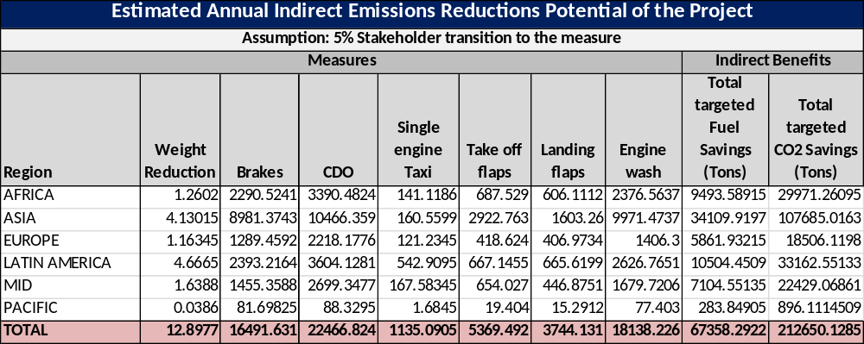

Over the project lifecycle, the indirect emissions reduction benefits are expected to range from 200,000 CO₂ tons if only 1% of the stakeholders transition, to 1 million CO₂ tons if 5% of the stakeholders transition to these cost effective measures. The methodology for this calculation is explained in Annex 7.5.

2.6 GEF eligibility

The project is designed to reduce GHG emissions from the international transport sector, and is therefore presented under GEF CCM Strategic Objective 4 - Promote energy efficient, low carbon transport and urban systems. Given the trans-boundary nature of the international aviation industry, the project promotes a global framework supportive of the adoption of low emission practices in international transport, facilitating and encouraging the participation of developing states.

Likewise, the implementation of low emission measures in developing States ensures investment in, and adoption of, innovative technologies. The implementation of a low emission aviation demonstration project in a SIDS is expected to be a first of a kind, flagship project for emission reductions in international aviation. As such, the demonstration component of the project is presented under CCM-1 – Promote the demonstration, deployment and transfer of low-carbon innovative technologies.

 |  | - Key Risks and Assumptions
# | Description |  | Date Identified | Type | Impact &  Probability | Countermeasures / Mngt response | Owner | Submitted, updated by | Last Update | Status
1 | Developing States do not prioritize emission reductions from international aviation. |  | PIF | Governance | I = 4  P = 2 | The project is embedded in a framework of multiple stakeholder discussions on emission reductions facilitated by ICAO, which has made significant progress in engaging all ICAO States.  The development of State Action Plans demonstrates a willingness to identify actions to reduce emissions according to national circumstances.  The possibility of engaging GEF and additional support for the implementation of such measures provides a greater incentive for developing States to join this effort. | Project Manager
2 | The aviation industry does not embrace the measures needed to achieve significant emission reductions from the sector. |  | PIF | Governance | I = 4  P = 1 | The commitments and voluntary targets established by the industry are a strong indicator that there is willingness to engage in low emissions aviation.  A key aspect is to ensure concerted action across the industry, so that the potential financial impact is not imbalanced across regions, thus affecting the competitiveness of the industry.  ICAO is at the forefront of this concerted action and has a successful track record of engaging the industry, which provides reassurance on the continued commitment of all associated stakeholders. | Project Manager
3 | Global economic conditions do not allow developing States and/or the aviation industry to invest in low emissions aviation. |  | PIF | Development | I = 4  P = 2 | International aviation is a highly competitive industry, which is particularly vulnerable to the state of the global economy. As such, the commitment to additional investment fluctuates according to global economic conditions.  The project seeks to minimize this risk by creating medium and long term market and regulatory conditions that establish a stable framework for investment in low emissions measures, regardless of global economic fluctuations.  Furthermore, State action plans will identify the most cost effective measures for implementation, thus creating a potential for increased competitiveness and costs savings through emission reductions. | Project Manager
4 | The Government of Jamaica withdraws its support to the project. |  | PPG | Governance | I = 2  P = 1 | The Government of Jamaica has agreed at the highest level to participate in the project. Letters of intent and support have been received by the Government of Jamaica and by CASSOS.  However, should the Government of Jamaica decide not to participate, ICAO has already identified other SIDS that fulfil the criteria established for this project and who have expressed interest in participating in the project. | Project Manager
5 | It is difficult to verify the GHG emission reductions delivered by the project. |  | PPG | Development | I = 3  P = 3 | The focus of this project is to assist ICAO Member States to reduce emissions from international aviation. Given the global scope, the verification of results is a key parameter not only of the demonstration component (Component 4) but of the whole project.  To verify emissions reductions from the demonstration component, an appropriate methodology will be used including continuous monitoring of electricity production from the PV panels.  For the other project components, information will be collected from States’ action plans and will be reviewed against relevant information from industry associations.  Throughout the duration of the project, ICAO will draw on technical knowledge and expertise to implement a robust monitoring and verification system, in collaboration with national and international experts. | Project Manager
6 | The unit cost of the PV panels would be too high for use in this project. |  | PPG | Development | I = 4  P = 1 | The unit cost of PV panels has decreased over the last few years. However, this issue was raised during PPG and it was decided to increase the budget for Component 4 to ensure that there are enough financial resources available for the installation of PV panels. | Project Manager
8 | Adverse social impacts (such as labour loss) would affect the introduction of renewable energy in international aviation. |  | PPG | Sustainability | P = 1  I = 2 | Replacing fossil fuels with RE may have impacts on labour demand, especially for oil production and processing.  The introduction of innovative technologies, however, presents new opportunities for employment, as well as improving local environmental conditions by reducing local pollution and noise. | Project Manager
9 | Exchange rate risk. |  | PPG | Financial | P = 2  I = 3 | The exchange rate between the US dollar and the Jamaican dollar may increase and/or fluctuate, potentially leading to a reduced value of GEF resources.  This external risk has affected the performance of other GEF Projects in developing countries.  Careful financial planning should help anticipate such a situation. | Project Manager

2.8 Innovativeness

This is the first global project funded by the GEF that aims to provide tools to developing States and SIDS to help them reduce emissions from international aviation, including the pilot activity of installing PV panels to demonstrate an innovative approach to reduce (and if possible eliminate) international aviation fuel used to run APUs at airports.

The impact of this project will be mostly systemic, as the strategy is to engage developing States in a medium and long term process to initially stabilize, and then reduce emissions from international aviation. Building upon the ICAO aspirational goals, the project aims to enable developing States and SIDs to define how they can contribute to the achievement of these global goals.

The aviation sector is symbolic of global connectivity and integration and is a rapid disseminator of technological innovation and best practices across the world. The project will create a platform to ensure that the transfer of technology and expertise reaches across all ICAO Member States. As such, the project will significantly contribute to a long term and high impact emission reduction process that will lead the international aviation sector on an environmentally sustainable path.

2.9 Stakeholders

The project will foster a partnership between UNDP, ICAO (including its 191 Member States) and the nominated ICAO National Action Plan Focal Points (more than 115 National Action Plan Focal Points have been nominated by their respective Governments). The project will engage with the aviation industry through various associations, such as: the International Air Transport Association (IATA) for air carriers; the Civil Air Navigation Services Organization (CANSO) for ANSPs; the Airports Council International (ACI) for airports; and the International Coordinating Council of Aerospace Industries Association (ICCAIA) for aerospace industries. The members of these organizations are well represented in the various CAEP working groups, and actively support the environmental tasks of ICAO.

Through this project, ICAO will also engage with an extensive network that covers the International Coalition for Sustainable Aviation (ICSA) representing non-governmental organizations, civil aviation authorities, airspace regulators, and industries providing emissions reduction services and products to users.

Furthermore, the ICAO CAEP will work to formulate new Standards and Recommended Practices (SARPs) related to aircraft noise and emissions, and more generally on aviation’s environmental impact. The resources provided by CAEP members and observers to conduct the work of CAEP is considered an in-kind contribution, taking into account the monetization of time, and human and technical resources spent by States and international organizations on undertaking CAEP-related activities .

The project will also engage the ICAO Technical Cooperation Bureau in terms of the procurement of goods and equipment, as well as for technical advice and field experience.

Other key stakeholders are international organizations with whom ICAO is coordinating to secure funding related to the development of the action plans and implementation of emissions reduction measures. ICAO established a partnership with the European Union (EU) to further assist States and reinforce/develop a capacity building project for CO₂ mitigation from international aviation.

ICAO will serve as a platform for engaging its Member States, National Action Plan Focal Points and other stakeholders during the project’s implementation, ensuring that the project reflects these stakeholders’ points of view and securing their commitment to delivering coordinated and reliable support.

The outreach and dissemination of materials developed during the project and of the results and lessons learnt will be conducted by ICAO in close cooperation and coordination with the various stakeholders so as to optimize the information sharing and increase the replicability of measures implemented by other ICAO States.

2.10 Sustainability (including financial sustainability)

The project aims to assist States to contribute to the sustainable development of international aviation. It promotes the strengthening of national capacities through the provision of appropriate material and guidance to developing States and SIDS in order to facilitate the implementation of cost effective mitigation measures that can generate a positive cash flow during their lifecycle. The Outcomes of Components 1 to 3 promote a better understanding among developing States and SIDS of the feasibility of these measures, as well as their environmental and financial benefits. They also enhance awareness among States on the various financing mechanisms that are available to implement these measures, without the need for additional grant support. As these additional activities are embedded in the framework of ICAO’s continuous support and engagement, these are not stand-alone measures. Furthermore, the lessons learnt from the implementation of the pilot project (Component 4, including installation of PV panels at an airport), along with the associated guidelines and policy recommendations, have the potential to become a model for many developing States and SIDS.

The installation of PV panels is the least sensitive to site selection among RE projects. PV panels offer one of the largest cost reduction potentials, have a life time of approximately 25 to 30 years and are relatively maintenance free. The pilot project is expected to have a pay-back period of about 8 to 16 years, making it financially sustainable. In addition to showcasing the technology, the project will demonstrate the revenue generation potential locked in in their airports from sales of surplus electricity from PV panels. With the price of PV panels expected to decrease further (see Annex 7.6), while their energy efficiency increases due to technology improvements, such as photon-enhanced thermionic emission, in the near term, many developing States and SIDS can be expected to replicate similar projects.

The financing opportunities for global scalability of the pilot project will be disseminated through Outcome 2 of this project. In many developed States the opportunity exists for the electricity producer to sell the electricity generated back to the grid, increasing the cost effectiveness of the installation. However, in many developing States such an opportunity does not exist; thus power generated by the solar installation would be consumed on-site to offset energy costs of the airport operator. A possible way around this would be to provide grants that would be used directly to offset the energy costs of the airport operator.

An alternative solution is financing provided by a vendor, who will provide turnkey solutions coupled with a fixed price power purchase agreement (PPA). Under this model the airport simply pays for the utility i.e. actual energy consumed, which could be the same as what the utility currently charge, but with the difference that the price is fixed for 20 to 25 years. This model would be extremely useful for the majority of airports in developing States who find it difficult to raise incremental finance to either install new, or convert existing infrastructure.

2.11 Replicability and continuity

Given the interest of several ICAO Member States which are in the process of implementing and/or planning to implement measures that reduce emissions from international aviation, the materials developed, results and lessons learnt from this project are expected to be of direct interest to many other States, which will facilitate replicability and implementation of incremental measures.

The project will seek to facilitate continuing engagement and cooperation between different stakeholders at the national and international level by organizing seminars, workshops and other outreach events, thereby bringing project proponents, government policy makers, potential investors and donors together.

All the project outcomes have been designed to contribute to the ongoing process within ICAO and its stakeholders to assist States in their activities to reduce emissions from international aviation and contribute towards the achievement of the ICAO aspirational goal of 2% annual fuel efficiency improvement. The project outcomes and the materials developed are expected to be integrated in the assistance work program of ICAO and its stakeholders
(co-financiers) ensuring institutional sustainability and continuity.

The successful completion of this project is expected to be a major driver in the ability of ICAO and its stakeholders to elicit further inputs and support for assistance-related activities in developing States leading to the efficient and effective provision of a continuing stream of assistance-related activities and outputs in developing States.

- Project Results Framework and BUDGET

3.1 Project Result Framework
Applicable ICAO Strategic Objective: Environmental Protection - Minimize the adverse environmental effects of civil aviation activities
Applicable ICAO Outcome: Availability of, and improved accessibility to technical and financial assistance to States
UNDP Strategic Programme Outcome: Growth and development are inclusive and sustainable, incorporating productive capacities that create employment and livelihoods for the poor and excluded
UNDP Strategic Programme Output: Scaled up action on climate change adaptation and mitigation across sectors which is funded and implemented
Applicable GEF Strategic Objective and Program: Objective 1- Promote the demonstration, transfer, and deployment of innovative low-carbon technologies and Objective 4 – Promote energy efficient, low carbon transport and urban systems
Applicable GEF Expected Outcomes: CCM1, Technologies successfully demonstrated, deployed, and transferred, and CCM4 Increased investment in less GHG intensive transport and urban systems.
Applicable GEF Outcome Indicators: Innovative low carbon technologies demonstrated and deployed on the ground, GHG Emissions avoided, Investment mobilized

Project Objective | Indicator | Baseline | Targets end of Project | Source of verification | Risks and Assumptions
To support capacity building in developing States for implementing technical and operational measures for reducing CO₂ emissions from international aviation. | Level of capacity of developing States and SIDS for implementing measures that reduce emissions from international aviation.  Demonstration of low emissions international aviation measures in the context of developing States and SIDS.  Amount of CO₂ emissions reduction facilitated by the investments of the Project from the four components. | Few SIDS’ national experts have information and access to tools to enable them to take decisions on implementation of actions to reduce CO₂ emissions from international aviation.  Very few emission reduction projects in developing States/SIDS are directly related to reducing emissions from international aviation.  Baseline emission reduction trends in international aviation as projected by ICAO , with limited participation of developing countries and SIDS. | At least 70% of SIDS with international aviation activity have been informed and provided access to outputs developed in the context of this project.  One pilot project is in place by the end of the project, and serves as a model for replication.  Direct: 17,500 tons of CO₂ over the 25 year timeline of the pilot investments made during the project implementation.  Indirect: Additional 1,000,000 tons of CO₂ reduced in developing countries and SIDS over 20 years. | Primary: Project monitoring reports and final evaluation.  Secondary: State action plans. | Low participation by developing States and SIDS and/or unwillingness to implement feasible measures.  Through the project, ICAO will actively engage developing States and SIDS to ensure that they have the necessary tools for the implementation of emissions reduction measures.
Outcome 1
More developing States and SIDS identify low emissions measures. | Level of understanding of costs and benefits of aviation mitigation measures in developing States and SIDS.  Number of developing States and SIDS with clearly identified feasible measures for implementation. | Limited knowledge of costs and benefits of aviation mitigation measures in the context of developing States and SIDS.  One third of developing States and SIDS have identified nationally-feasible measures. | Costs and benefits of low emissions aviation clearly understood in developing States and SIDS due to assessment tools developed by the project.  At least 10 additional developing States and SIDS have identified country specific mitigation measures. | Primary: Guidelines on cost and environmental benefits of the basket of measures developed by project.  Project monitoring reports and final evaluation.  Secondary: State action plans | State may be unwilling or unable to identify feasible measures.
Outcome 2
Instruments are available to support the development of a legal and regulatory environment that facilitates the financing of feasible low emissions aviation measures in States. | Level of implementation of low emission aviation policy and regulation in developing States and SIDS.  Level of technical knowledge in developing States and SIDS regarding drop-in biofuels and renewable energy for airport operations. | Low level of implementation of low emission aviation policy and regulation in developing States and SIDS.  Limited technical knowledge in developing States and SIDS regarding drop-in biofuels and renewable energy for airport ground operations. | Policies and regulations guidelines are adopted to stimulate low emission aviation investments in developing States and SIDS.  Technical knowledge on drop in biofuels and renewable energy projects in airports increased due to technical guidance developed by the project. | Policy and regulation guidelines are developed by project .  Guidelines targeted to developing States and SIDS for  a)Drop-in  biofuels for international aviation; and  b)Renewable energy for airport ground operations in developing States and SIDS  Project monitoring reports and final evaluation. | The proposed guidelines and policy recommendations that support the implementation of emissions reduction measures go through the approval processes in developing States and SIDS.
Outcome 3
The cost and resources expended by developing States and SIDS to have access to updated technical information on low emission mitigation measures is greatly minimized. | Level of technical support provided by ICAO to developing States and SIDS.  Level of technical information for low emissions aviation provided by key stakeholders in the technical platform.  Level of use of technical support platform by developing States and SIDS. | Limited technical support targeted to developing States and SIDS provided by baseline programme  Technical information provided in a dispersed, ad hoc manner by individual stakeholders.  Technical support platform not developed. | Enhanced technical support provided to developing countries and SIDS through a technical support platform.  Technical support platform provides information in a coordinated and organized manner , incorporating information from airlines, airport managers, air transport authorities, manufacturers, and other key international aviation stakeholders.  Developing States and SIDS use the platform on a regular basis to access relevant technical information, as measured by database usage statistics. | ICAO technical support platform  Project monitoring reports and final evaluation. | The technical support platform is used/ adopted by the developing State and SID State.
Outcome 4
The feasibility of implementing low emissions aviation measures is demonstrated through the pilot project and the lessons learnt are made available to facilitate the replication in developing States and SIDS. | Level of experience in implementation of low emissions projects in SIDS  Direct emission reductions resulting from demonstration project.  Level of awareness of low emission aviation project feasibility in developing States and SIDS. | No low emission international aviation project in a SIDS.  No pilot project in place  Limited knowledge on the feasibility of low emissions aviation projects in developing States and SIDS context. | Low emission pilot project is fully implemented and operational in a SIDS.  At least 17,500 tons of CO₂ reduced by the demonstration project (over project lifetime)  Increased confidence/ knowledge in feasibility of low emissions aviation projects in developing States and SIDS as a result of dissemination of pilot project results. | Project monitoring reports and final evaluation. | SIDS participation and willingness to implement pilot project.

3.2 Total budget and work plan (see budget note in annex 7.7)
Award ID: | 00082348 | Project ID | 00091318
Award Title: | Transforming the Global Aviation Sector: Emissions Reductions form the International Aviation
Business Unit: | UNDP1
Project Title: | Transforming the Global Aviation Sector: Emissions Reductions form the International Aviation
PIMS No. | 5254
Implementing Partner: | International Civil Aviation Organization

GEF Outcome/Atlas Activity | Responsible Party/  Implementing Agent | Fund ID | Donor Name | Atlas Budgetary Account Code | ATLAS Budget Description | Amount Year 1 (USD) | Amount Year 2 (USD) | Amount Year 3 (USD) | Total (USD)
OUTCOME 1: More developing States and SIDS identify low emissions measures in developing States and SIDS | ICAO | 62000 | GEF | 71200 | International Consultants | 12,996 | 12,996 | 0 | 25,992
 |  |  |  | 71300 | Local Consultants | 13,950 | 13,950 | 13,950 | 41,850
 |  |  |  | 72100 | Contractual services  companies | 100,000 | 100,000 | 0 | 200,000
 |  |  |  | 71600 | Travel | 21,200 | 0 | 0 | 21,200
 | ICAO |  |  | 72400 | Commun & Audio Visual Equip | 0 | 5,000 | 0 | 5,000
 | ICAO |  |  | 74200 | Audio visual & Print Prod Costs | 0 | 6,000 | 0 | 6,000
 | ICAO |  |  |  | Total Outcome 1 | 148,146 | 137,946 | 13,950 | 300,042
OUTCOME 2: Instruments are available to support the development of a legal and regulatory environment that facilitates the financing of feasible low emissions aviation measures in States | ICAO | 62000 | GEF | 71200 | International Consultants | 24,246 | 151,556 | 18,441 | 194,243
 |  |  |  | 71300 | Local Consultants | 13,950 | 13,950 | 13,950 | 41,850
 |  |  |  | 74200 | Audio visual & Print Prod Costs | 0 | 4,375 | 4,375 | 8,750
 | ICAO |  |  |  | Total Outcome 2 | 38,196 | 169,881 | 36,766 | 244,843
OUTCOME 3: The cost and resources expended by ICAO developing States and SIDS to have access to updated technical information on low emission mitigation measures is greatly minimized. | ICAO | 62000 | GEF | 71200 | International Consultants | 9,496 | 76,144 | 0 | 85,640
 |  |  |  | 71300 | Local Consultants | 13,950 | 13,950 | 13,950 | 41,850
 |  |  |  | 71600 | Travel | 0 | 12,800 | 0 | 12,800
 |  |  |  | 72400 | Commun & Audio Visual Equip | 2,000 | 2,000 | 2,000 | 6,000
 |  |  |  | 74200 | Audio visual & Print Prod Costs | 3,000 | 3,000 | 3,000 | 9,000
 | ICAO |  |  |  | Total Outcome 3 | 28,446 | 107,894 | 18,950 | 155,290
OUTCOME 4: The feasibility of implementing low emissions aviation measures is demonstrated through the pilot project and the lessons learnt are made available to facilitate the replication in developing states. | ICAO | 62000 | GEF | 71300 | Local Consultants | 13,950 | 13,950 | 13,950 | 41,850
 |  |  |  | 71600 | Travel | 0 | 0 | 30,000 | 30,000
 |  |  |  | 72100 | Contractual Services Companies | 0 | 0 | 1,050,000 | 1,050,000
 | ICAO |  |  |  | Total Outcome 4 | 13,950 | 13,950 | 1,093,950 | 1,121,850
Project Management | ICAO | 62000 | GEF | 71200 | International Consultants | 0 | 0 | 31,000 | 31,000
 |  |  |  | 71400 | Contractual Services (Indv) | 29,325 | 29,325 | 29,325 | 87,975
 |  |  |  | 74100 | Professional Services | 3,000 | 3,000 | 3,000 | 9,000
Project Management | ICAO |  |  |  | Total Management | 32,325 | 32,325 | 63,325 | 127,975
 |  |  |  |  | PROJECT TOTAL | 261,063 | 461,996 | 1,226,941 | 1,950,000

Full Budget notes are included in Annex 7.7

3.3 Summary of Funds

 | Amount Year 1 | Amount Year 2 | Amount Year 3 | Total
GEF | 261,063 | 461,996 | 1,226,941 | 1,950,000
CAEP and Member States | 800,000 | 800,000 | 1,400,000 | 3,000,000
ICAO Budget | 500,000 | 500,000 | 500,000 | 1,500,000
Multilateral agency (EU) | 1,699,000 | 1,673,000 | 4,878,000 | 8,250,000
UNDP | 100,000 | 100,000 | 100,000 | 300,000
Total | 3,360,063 | 3,534,996 | 8,104,941 | 15,000,000

Note: Co-financing letter is in Annex 7.8

Co- financing does not include land that will be made available as indicated in the letter from the Jamaica Civil Aviation Authority (Annex 7.2 ).

Management Arrangements
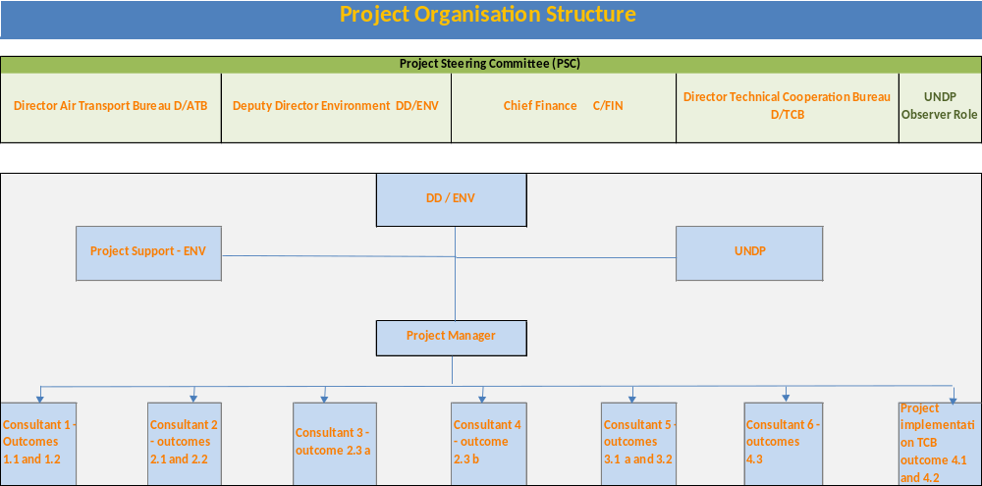
The ICAO/UNDP Assistance Project “Transforming the Global Aviation Sector: Emissions Reduction from International Aviation” will be managed as described below.
A Project Steering Committee (PSC) will be established at the inception of the project to monitor project progress, to guide project implementation including financial aspects and to support the project in achieving the components and outcomes. The PSC will meet on a regular basis and at least 6 times per year.
The Director of the Air Transport Bureau (D/ATB), the Deputy Director, Environment (DD/ENV), the Chief, Finance (C/FIN), and the Director of the Technical Cooperation Bureau (D/TCB) will compose this Committee, with the participation of UNDP as an observer.
Other members can be invited at the decision of the PSC on an as-needed basis, but taking due regard that the PSC remains sufficiently lean to be operationally effective. Any inclusions to the PSC shall be reported in the inception report.
The PSC will be responsible for the general supervision of the project. The project manager will report to the PSC through DD/ENV.

The project manager (provisional ToRs in Annex 7.9) will carry out the day-to-day management of the project. He/She will be assisted by other consultants (consultants 1 to 6 in the schematic above), and will operate in close cooperation with ICAO ENV and ICAO TCB as appropriate.

The implementation of the Component 4 Outcomes 4.1 and 4.2 of the project will be undertaken through TCB under the direct guidance/supervision of DD/ENV and in coordination with the project manager and UNDP.

The GEF will be kept informed of all project activities through annual implementation reports (PIRs) and any modifications to the project strategy will seek approval as per standard GEF procedures.

Monitoring Framework and Evaluation (M&E)
The project will be monitored through the following M&E activities. The M& E budget is provided in Table 5.

Project start:
A Project Inception Workshop will be held within the first 2 months of the project start and will be attended by those with assigned roles in the project organization structure, UNDP GEF, and where appropriate/feasible, regional technical policy and programme advisors, as well as other stakeholders. The Inception Workshop is crucial to building ownership for the project results and to planning the first year annual work plan.

The Inception Workshop should address a number of key issues including:
- Assist all partners to fully understand and take ownership of the project. Detail the roles, support services and complementary responsibilities of UNDP GEF staff vis à vis the project team. Discuss the roles, functions, and responsibilities within the project's decision-making structures, including reporting and communication lines, and conflict resolution mechanisms. The Terms of Reference for project staff will be discussed again, as needed.
- Based on the project results framework and the relevant GEF Tracking Tool if appropriate, finalize the first annual work plan. Review and agree on the indicators, targets and their means of verification, and recheck assumptions and risks.
- Provide a detailed overview of reporting, monitoring and evaluation requirements. The M&E work plan and budget should be agreed and scheduled.
- Discuss financial reporting procedures and obligations, and arrangements for annual audit.
- Plan and schedule Project Board meetings. Roles and responsibilities of all project organisation structures should be clarified and meetings planned. The first Project Board meeting should be held within the first 12 months following the Inception Workshop.

An Inception Workshop report is a key reference document and must be prepared and shared with participants to formalize various agreements and plans decided during the meeting.

Quarterly:
- Progress made shall be monitored in the UNDP Enhanced Results Based Managment Platform.
- Based on the initial risk analysis submitted, the risk log shall be regularly updated in ATLAS. Risks become critical when the impact and probability are high. Note that for UNDP GEF projects, all financial risks associated with financial instruments such as revolving funds, microfinance schemes, or capitalization of ESCOs are automatically classified as critical on the basis of their innovative nature (high impact and uncertainty due to no previous experience justifies classification as critical).
- Based on the information recorded in Atlas, a Project Progress Reports (PPR) can be generated in the Executive Snapshot.
- Other ATLAS logs can be used to monitor issues, lessons learned etc. The use of these functions is a key indicator in the UNDP Executive Balanced Scorecard.

Annually:
- Annual Project Review/Project Implementation Reports (APR/PIR): This key report is prepared to monitor progress made since the project start and in particular, for the previous reporting period (30 June to 1 July). The APR/PIR combines both UNDP and GEF reporting requirements.
The APR/PIR includes, but is not limited to, reporting on the following:
- Progress made toward project objectives and project outcomes, each with indicators, baseline data and end-of-project targets (cumulative).
- Project outputs delivered per project outcome (annual).
- Lesson learnt/good practice.
- AWP and other expenditure reports.
- Risk and adaptive management.
- ATLAS QPR.
- Portfolio level indicators (i.e. GEF focal area tracking tools) are used by most focal areas on an annual basis as well.

Periodic Monitoring through site visits:
UNDP GEF will conduct visits to project sites based on the agreed schedule in the project's Inception Report/Annual Work Plan to assess first hand project progress. Other members of the Project Board may also join these visits. A Field Visit Report/BTOR will be prepared by the UNDP GEF and will be circulated no less than one month after the visit to the project team and Project Board members.

End of Project:
An independent Final Evaluation will take place three months prior to the final Project Board meeting and will be undertaken in accordance with UNDP and GEF guidance. The final evaluation will focus on the delivery of the project’s results as initially planned (and as corrected after the mid-term evaluation, if any such correction took place). The final evaluation will look at the impact and sustainability of results, including the contribution to capacity development and the achievement of global environmental benefits/goals. The Terms of Reference for this evaluation will be prepared by the UNDP based on guidance from GEF.

The Terminal Evaluation should also provide recommendations for follow-up activities and requires a management response which should be uploaded to PIMS and to the UNDP Evaluation Office Evaluation Resource Center (ERC).

The relevant GEF Focal Area Tracking Tools will also be completed during the final evaluation.

During the last three months, the project team will prepare the Project Terminal Report. This comprehensive report will summarize the results achieved (objectives, outcomes, outputs), lessons learnt, problems encountered and areas where results may not have been achieved. It will also lay out recommendations for any further steps that may need to be taken to ensure sustainability and replicability of the project’s results.

Learning and knowledge sharing:
Results from the project will be disseminated within and beyond the project intervention zone through existing information sharing networks and forums.
The project will identify and participate, as relevant and appropriate, in scientific, policy-based and/or any other networks, which may be of benefit to project implementation though lessons learnt. The project will identify, analyse, and share lessons learnt that might be beneficial in the design and implementation of similar future projects.
Finally, there will be a two-way flow of information between this project and other projects of a similar focus.

Communications and visibility requirements:
Full compliance is required with UNDP’s Branding Guidelines. These can be accessed at http://intra.undp.org/coa/branding.shtml, and specific guidelines on the use of the UNDP logo can be accessed at: http://intra.undp.org/branding/useOfLogo.html. Amongst other things, these guidelines describe when and how the UNDP logo needs to be used, as well as how the logos of donors to UNDP projects needs to be used. For the avoidance of any doubt, when logo use is required, the UNDP logo needs to be used alongside the GEF logo. The GEF logo can be accessed at: http://www.thegef.org/gef/GEF_logo. The UNDP logo can be accessed at http://intra.undp.org/coa/branding.shtml.

Full compliance is also required with the GEF’s Communication and Visibility Guidelines (the “GEF Guidelines”). The GEF Guidelines can be accessed at: http://www.thegef.org/gef/sites/thegef.org/files/documents/C.40.08_Branding_the_GEF%20final_0.pdf. Amongst other things, the GEF Guidelines describe when and how the GEF logo needs to be used in project publications, vehicles, supplies and other project equipment. The GEF Guidelines also describe other GEF promotional requirements regarding press releases, press conferences, press visits, visits by Government officials, productions and other promotional items.

Where other agencies and project partners have provided support through co-financing, their branding policies and requirements should be similarly applied.

Audit Clause:
The audit of programmes and projects managed by a UN Agency is carried out by the duly appointed auditors of that agency. The audit must be conducted in conformity with generally accepted common auditing standards and in accordance with the professional judgment of the auditor. The audit may refer to the standards and terms of reference established for the United Nations Board of Auditors.

5.1 Monitoring & Evaluation work plan and budget

Table 5: Monitoring framework and Evaluation – work plan and budget.
Type of M&E activity | Responsible Parties | Budget US$  Excluding project team staff time | Time frame
Inception Workshop and Report | - ICAO  - UNDP GEF | Indicative cost: 10,000 | Within first two months of project start up
Measurement of Means of Verification of project results | - UNDP GEF /ICAO will oversee the hiring of specific studies and institutions, and delegate responsibilities to relevant team members. | To be finalized during Inception Phase and Workshop. | Start, mid and end of project (during evaluation cycle) and annually when required
Measurement of Means of Verification for Project Progress on output and implementation | - Oversight by ICAO  - Project team | To be determined as part of the Annual Work Plan's preparation | Annually prior to ARR/PIR and to the definition of annual work plans
ARR/PIR | - ICAO  - UNDP GEF | None | Annually
Periodic status/ progress reports | - ICAO | None | Quarterly
Final Evaluation | - ICAO  - UNDP GEF  - External Consultants (i.e. evaluation team) | Indicative cost: 40,000 | At least three months before the end of project implementation
Project Terminal Report | - ICAO  - UNDP GEF  - local consultant | 0 | At least three months before the end of the project
Audit | - UNDP GEF  - ICAO | Indicative cost per year: 3,000 | Yearly
Visits to field sites | - UNDP GEF  - Government representatives  - ICAO | For GEF supported projects, paid from IA fees and operational budget | Yearly
TOTAL indicative COST  Excluding project team staff time and UNDP staff and travel expenses |  | US$ 59,000

Legal Context
This project forms part of an overall programmatic framework under which several separate associated country level activities will be implemented. When assistance and support services are provided from this Project to the associated country level activities, this document shall be the “Project Document” instrument referred to in: (i) the respective signed SBAAs for the specific States; or (ii) in the Supplemental Provisions attached to the Project Document in cases where the recipient country has not signed an SBAA with UNDP, attached hereto and forming an integral part hereof.

This project will be implemented by the International Civil Aviation Organization, ICAO (“Implementing Partner”) in accordance with its financial regulations, rules, practices and procedures only to the extent that they do not contravene the principles of the Financial Regulations and Rules of UNDP. Where the financial governance of an Implementing Partner does not provide the required guidance to ensure best value for money, fairness, integrity, transparency, and effective international competition, the financial governance of UNDP shall apply.

The responsibility for the safety and security of the Implementing Partner and its personnel and property, and of UNDP’s property in the Implementing Partner’s custody, rests with the Implementing Partner. The Implementing Partner shall: (a) put in place an appropriate security plan and maintain the security plan, taking into account the security situation in the country where the project is being carried; (b) assume all risks and liabilities related to the Implementing Partner’s security, and the full implementation of the security plan. UNDP reserves the right to verify whether such a plan is in place, and to suggest modifications to the plan when necessary. Failure to maintain and implement an appropriate security plan as required hereunder shall be deemed a breach of this agreement.

The Implementing Partner agrees to undertake all reasonable efforts to ensure that none of the UNDP funds received pursuant to the Project Document are used to provide support to individuals or entities associated with terrorism and that the recipients of any amounts provided by UNDP hereunder do not appear on the list maintained by the Security Council Committee established pursuant to resolution 1267 (1999). The list can be accessed via http://www.un.org/Docs/sc/committees/1267/1267ListEng.htm. This provision must be included in all sub-contracts or sub-agreements entered into under this Project Document.

Annexes
Annex 7.1: Basket of measures to limit or reduce GHG emissions from international civil aviation

1. Aircraft-related technology development

a) aircraft minimum fuel efficiency standards;

b) aggressive aircraft fuel efficiency standards, setting standards for the future;

c) purchase of new aircraft;

d) retrofitting and upgrade improvements on existing aircraft;
i. improve fuel efficiency through development of modification (wingtip fence, blended
winglet/sharklets, raked wingtip, etc., drag reduction, turbulent flow drag coatings, high power LEDs, wireless/optical connections)
ii. replacement of engines
iii. replacement or modification of avionics
iv. other

e) optimizing improvements in aircraft produced in the near- to mid-term;
i. maximising contribution of lightweight materials in aircraft planned for the near future
ii. maximising contribution of engine technology in aircraft planned for the near future
iii. maximising contribution of auxiliary power sources in aircrafts planned for the near future
iv. other

f) avionics;

g) adoption of revolutionary new designs in aircraft/engines;
i. open rotor
ii. blended wing body
iii. improved laminar flow
iv. other

h) other.

2. Alternative fuels

a) development of biofuels;

b) development of other fuels with lower life-cycle CO₂ emissions;

c) standards/requirements for alternative fuel use;

d) other.

3. Improved air traffic management and infrastructure use

a) more efficient ATM planning, ground operations, terminal operations (departure, approach and arrivals), en-route operations, airspace design and usage, aircraft capabilities;
i. measures to improve pre-departure planning (DMAN)
ii. measures to improve ground operations
iii. measures to improve collaborative decision making (A-CDM)
iv. measures to improve the use of optimum flight levels
v. measures to improve the use of optimum routings
vi. measures to improve flexible tracks
vii. measures to improve fuel efficient departure and approach procedures (PBN STAR, CCO,
CDO)
viii. measures to fully utilize RNAV/RNP capabilities
ix. measures to improve flexible use of civil-military airspace
x. other

b) more efficient use and planning of airport capacities;
i. measures to improve taxiing
ii. measures to improve parking
iii. measures to enhance terminal support facilities
iv. measures to plan new capacity when bottlenecks cause environmental problems
v. other

c) collaborative research endeavours;
i. AIRE
ii. ASPIRE
iii. other

d) other.

4. More efficient operations

a) best practices in operations – ICAO Doc 10013
i. minimising weight
ii. minimising flaps (take-off and landing)
iii. minimising reversers use
iv. single engine taxi
v. E-Taxi (only for A320 and B737)
vi. improving load factors
vii. reduced speed
viii. improved ground operations
ix. training pilots
x. other

b) optimized aircraft maintenance;
i. engine wash
ii. aircraft wash
iii. zonal dryer
iv. other

c) selecting aircraft best suited to the mission;

d) other.

5. Economic/market-based measures

a) voluntary inclusion of aviation sector in market-based measures;

b) incorporation of emissions from international aviation into regional or national market-based measures, in accordance with relevant international instruments;

c) establishment of a multilateral emissions trading scheme for aviation which allows trading permits with other sectors, in accordance with relevant international instruments;

d) establishment of a framework for linking existing emissions trading schemes and providing for their extension to international aviation, in accordance with relevant international instruments;

e) emissions charges or modulation of landing/take-off (LTO) charges, in accordance with relevant international instruments;
i. NOx charges
ii. fuel charges
iii. other

f) positive economic stimulation by regulator;
i. research programs
ii. special consideration and government programs/legislation
iii. accelerated depreciation of aircraft
iv. other

g) accredited offset schemes;

h) explore extension of Clean Development Mechanism (CDM) for domestic emissions;

- taxation of aviation fuel, in accordance with relevant international instruments;

j) other.

6. Regulatory measures/other

a) airport movement caps/slot management;

b) enhancing weather forecasting services;

c) requiring transparent carbon reporting;

d) conferences/workshops;

e) other.

7. Airport improvements

a) airfield improvements;
i. installation of LED instead of classic light
ii. construction of runways
iii. construction of taxiways
iv. construction of additional taxiway-exits and/or speed-exit (allowing aircrafts to leave runways at
higher speed)
v. installation of fixed electrical ground power and pre-conditioned air to allow aircraft APU switch-
off
vi. other

b) reduced energy demand and preferred cleaner energy sources;
i. use cleaner alternative sources of power generation (photovoltaic panels, wind generators)
ii. use cleaner heater / cooler equipment and/or minimize heater / cooler utilization
iii. reduce electrical demand (switch off unnecessary lights, promote stairs instead of lifts, etc.)
iv. other

c) enhanced GSE (Ground Support Equipment) management;
i. reduce distance travelled
ii. avoid unnecessary idling of equipment
iii. other

d) conversion of GSE to cleaner fuels;
i. electrical operated ground vehicles
ii. gas operated ground vehicles
iii. biofuel operated ground vehicles
iv. other

e) improved transportation to and from airport;
i. improved public transport access
ii. improved employee transportation
iii. other

f) other.

Annex 7.2: Endorsement Letters.

Extract from the 38th session of the ICAO General Assembly held in Montréal, Canada, from 24 September to
4 October 2013.

The ICAO Secretariat was mandated by its Member States to continue to play a pivotal role in providing assistance to its Member States and to facilitate the access to existing and new financial resources.

Resolution A38-18: | Consolidated statement of continuing ICAO policies and practices related to environmental protection – Climate change
[……]
Noting that, consistent with Assembly Resolution A37-19, a substantial strategy for capacity building was undertaken by the Organization to assist the preparation and submission of States’ action plans, including the holding of hands-on training workshops and the development of guidance material, an interactive web-interface and the ICAO Fuel Savings Estimation Tool (IFSET);
Welcoming that, as of 30 June 2013, 61 member States that represent 78.89 per cent of global international air traffic voluntarily prepared and submitted their action plans to ICAO;
Noting that the ICAO “Assistance for Action – Aviation and Climate Change” Seminar in October 2012 highlighted the active involvement of member States and international organizations in the activities related to States’ action plans, explored possible sources of financial support for environmental action and provided an opportunity to share information and build partnerships in order to facilitate assistance identified by States for the preparation and implementation of their action plans;
Recognizing the different circumstances among States in their capacity to respond to the challenges associated with climate change and the need to provide necessary support, in particular to developing countries and States having particular needs;
Affirming that specific measures to assist developing States as well as to facilitate access to financial support, technology transfer and capacity building should be initiated as soon as possible;
[…..]
31. Requests the Council to:
a) continue to play a pivotal role in providing assistance to its member States through the dissemination of the latest information on best practices and the provision of guidance and other technical assistance to enhance capacity building and technology transfer, including through the ICAO Technical Cooperation Programme;
b) consolidate and build on the partnership with other international organizations to meet the assistance needs of ICAO’s member States, including through their action plans, which will bring about reductions in international aviation emissions;
c) initiate work immediately and as a priority in order to develop a process and mechanisms to facilitate the provision of technical and financial assistance, as well as facilitate access to existing and new financial resources, technology transfer and capacity building, to developing countries and report on results achieved as well as further recommendations, preliminarily by the end of 2015 and at the 39th Session of the Assembly; and
d) continue to initiate specific measures to assist developing States as well as to facilitate access to financial resources, technology transfer and capacity building; […..]

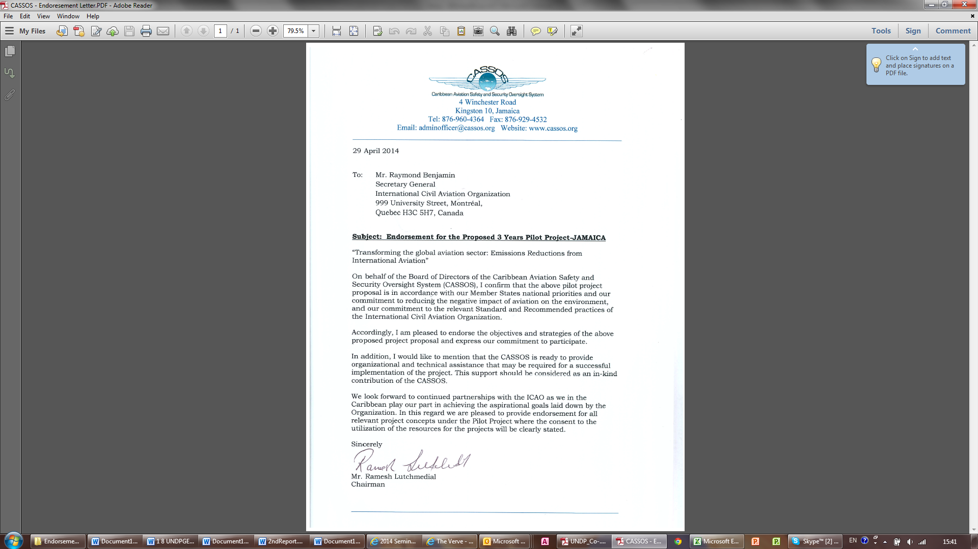

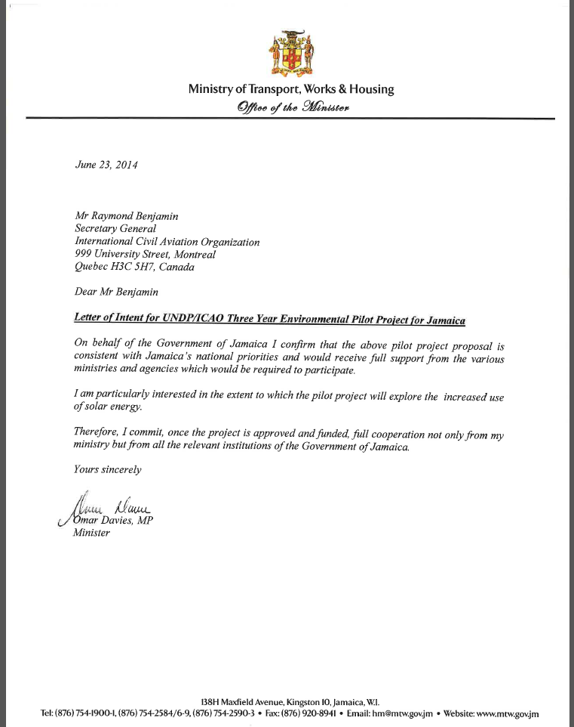

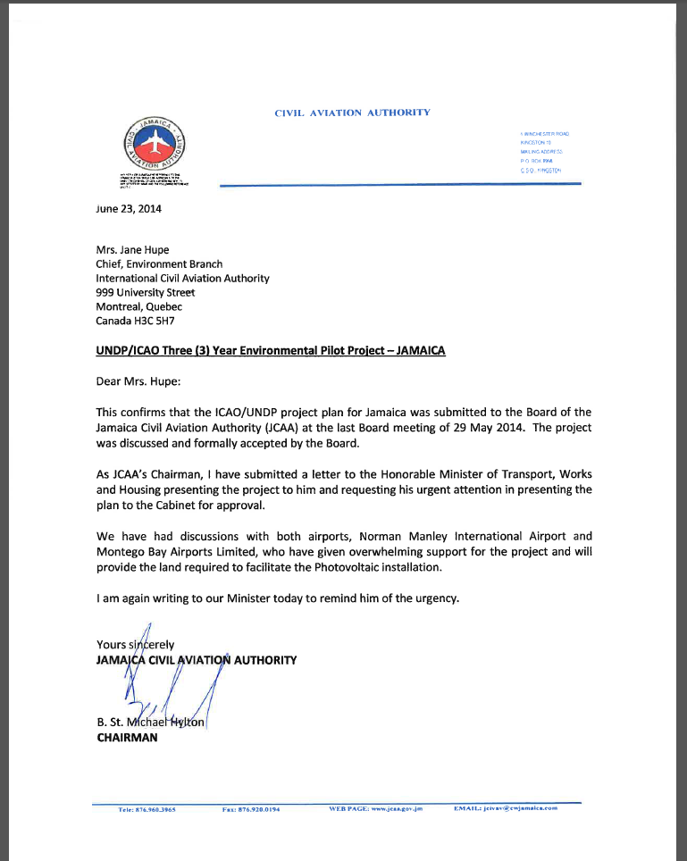

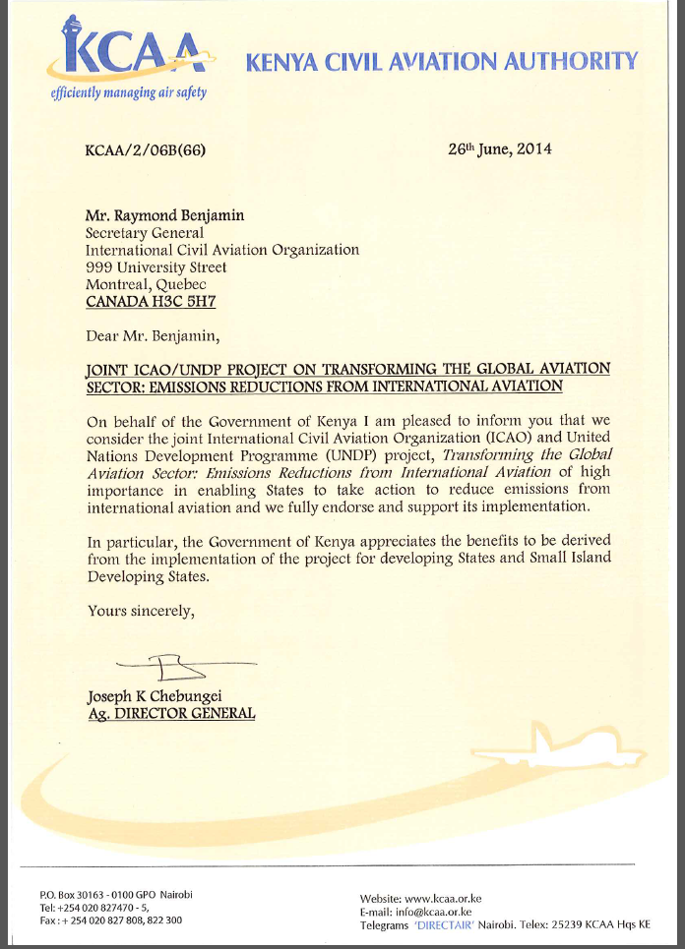

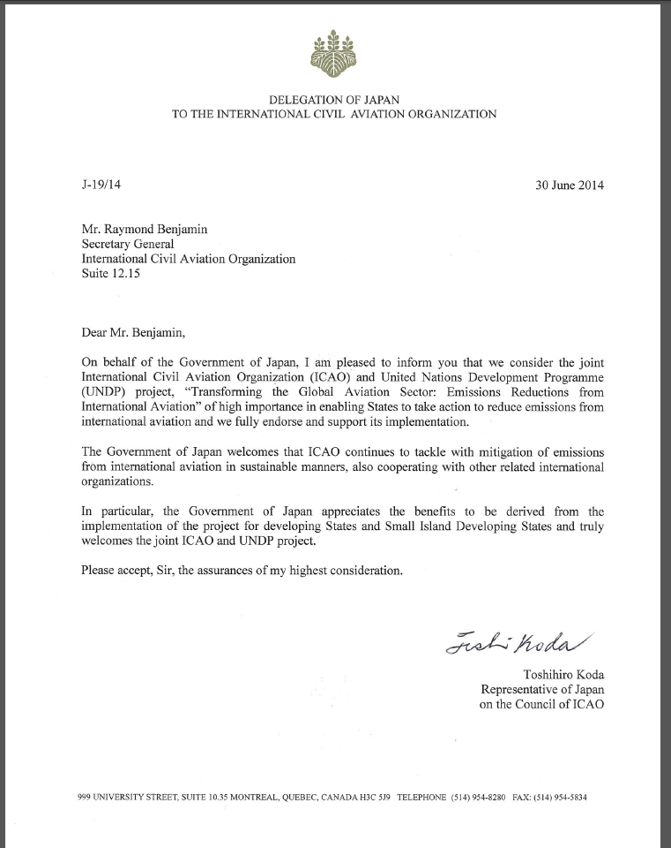

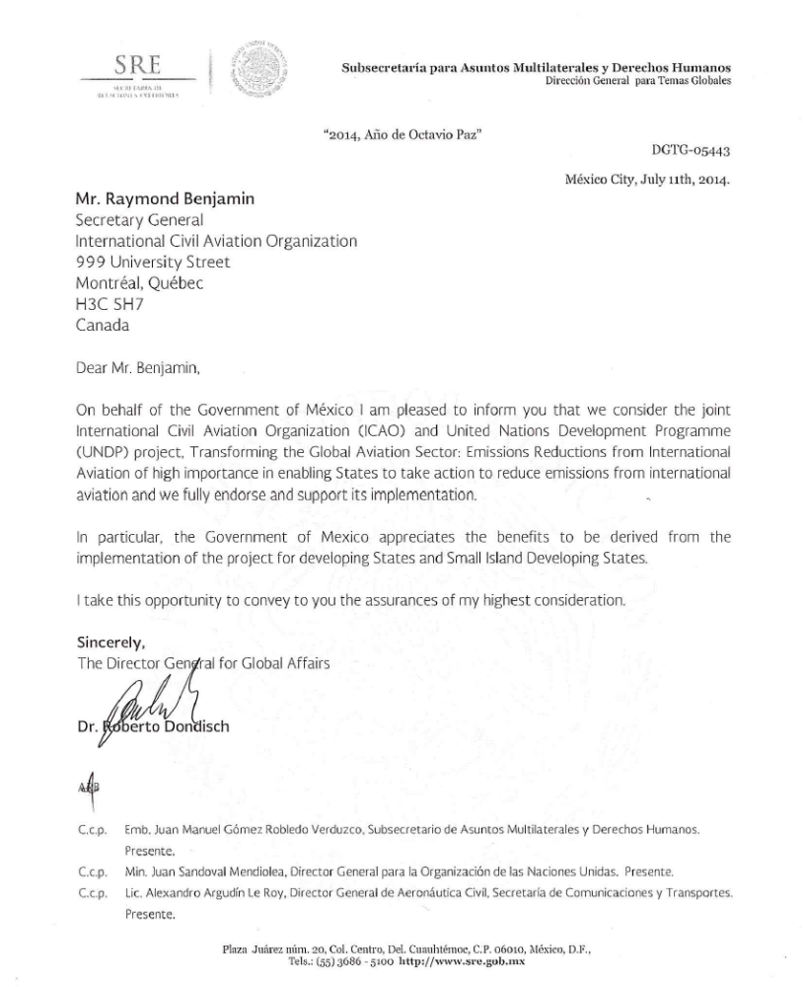

Annex 7.3: Global Mean Solar Irradiance

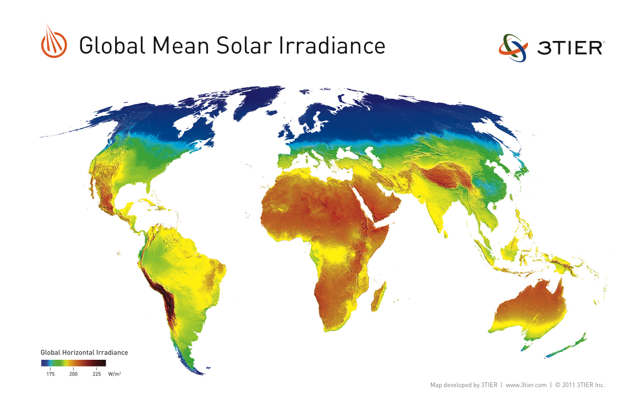

The Global Horizontal Irradiance (GHI) is the total amount of shortwave radiation received from above by a surface horizontal to the ground.

The units for all of these quantities are watts per square meter (W/m2)

Annex 7.4: Cost in USD per incremental KWH reduction

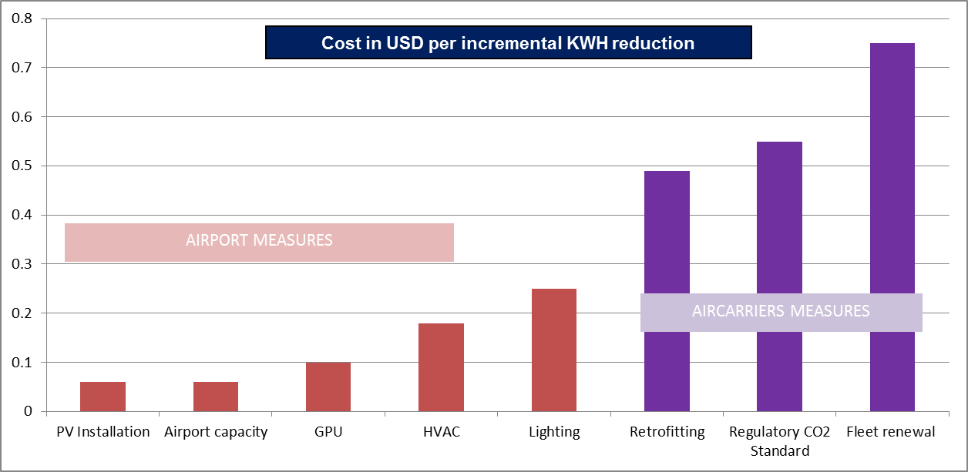

Source: Marginal cost abatement study of AEA and EMRC, data collected by ICAO from stakeholders.

Annex 7.5: Methodology of Direct and Indirect Benefits Calculations

1.1 Direct Emissions benefits
The direct emissions benefits from installing solar panels in an airport (Table 1: Factors to consider for solar panel project implementation in airports, pg. 21) and section 2.5.1 (pg. 24) was obtained from a compilation of data received from five different vendors specialized in this activity. Data collected by the vendors relating to a standard solar installation in a 1 acre available area with accompanying technical information was compiled and averaged in order to derive the optimal kilowatt energy that could be generated. This was converted to kilowatt hours (kWh) using a solar generation at the airport for 2000 hours in a year emissions reductions benefits expected from the installation. The kWh of energy that will be now generated using solar as opposed to fossil energy was converted to emissions (CO₂) reduction using the factors available with the Energy Information Administration of the United States. Agency (EIA) (http://www.eia.gov/tools/faqs/faq.cfm?id=74&t=11).

1.2 Indirect emissions benefits
From Replication of Outcomes in Component 4
The indirect emissions benefits expected from the replication of the direct emissions benefits as indicated in paragraph 2.5.2.1 (pg. 24) is based on a scenario where 200 airports in developing States replicate the pilot project. An analysis conducted using proprietary data with ICAO indicated that there were around 1,500 airports in developing States and SIDS. Of these, the replicability potential was restricted only to those approximately 200 airports of developing States and SIDS whose CO₂ emissions as a percentage of total emissions in the region of the airport was >=1%. These are indicated under paragraph 2.5.2.1, Table 2.

The range of CO₂ emissions reduction benefits if 200 airports out of the 1,500 replicate the pilot project is displayed in bands of 5% to 100% i.e. 10 to 200 airports and indicated in paragraph 2.5.2.1, Table 3. The annual indirect CO₂ emissions reduction of these airport bands is essentially an extrapolation of the direct emissions benefits arrived for a single airport using the methodology mentioned in the paragraph 1.1. above. A very conservative range of 5% to 10% i.e. 10 to 20 airports has been used to arrive at the indirect emissions reduction benefit potential from replication of 180,000 to 360,000 tons during the lifecycle of the project.

From Replication of Outcomes in Component 1 to 3
The indirect emissions benefits expected from the replication of the indirect emissions benefits as indicated in paragraph 2.5.2.2 is arrived at by using vendor obtained data on the costs and environmental benefits of implementing a range of measures. These costs and benefits were logged into a database and related to proprietary scheduled operational data with ICAO. The result gave ICAO the range of measures (see paragraph 2.5.2.2, Table 4) that could be potentially implemented as they are the most cost effective to implement. The initial analysis was performed for the operations at the air carrier level and then scaled up to a regional level using the following rules:

Fuel savings estimation by air carrier

1. Weight reduction (Unit Load Device (ULD), seat, carpet and carbon brakes):

To estimate fuel savings by reducing weight in aircraft, different Rules have been developed based on the main Rule of Thumb :
Fuel savings (kg) = 3.06% * Weight reduction (kg) * Flight time (hour)
The following table shows the Rules by measure.
Measure | Rules
ULD | 0.49 kg of fuel / hour / ULD
Seat | 0.14 kg of fuel / hour / seat
Carpet | 0.01 kg of fuel / hour / m²
Carbon brakes | NB : 8.5 kg of fuel / hour / aircraft  WB : 10.41 kg of fuel / hour / aircraft

A database was created to compile all information (number of ULDs, number of seat, cabin dimension) per aircraft type. Once the database was done, information has been linked to the traffic database to estimate potential fuel savings per carrier.

2. E-Taxi and Single engine taxiing

The Rule for the E-Taxi is equal to 10.41 kg of fuel per minute (only available for B737 and A320). Fuel saving for the single engine taxiing is equal to 28% of fuel burn (idle). Once again, a potential fuel savings was estimated by carrier by using departure and arrival information. The main assumption below both measures is a taxi-in time of 10 minutes and a taxi-out time of 10 minutes.

3. Continuous Descent Operation

Fuel savings per CDO for a Narrow-body aircraft is around 82.5 kg and for a Wide-body aircraft is around 125.5 kg. Fuel savings estimation per carrier was made by using arrival information.

4. Takeoff and landing flaps

Fuel savings by reducing flaps during a takeoff for a Narrow-body is 10 kg and 60 kg for a Wide-body. Fuel savings by reducing flaps during a landing for a Narrow-body is 17 kg and 20 kg for a Wide-body.
Once again, fuel savings estimation was made per carrier and by using takeoff and landing information.

5. Engine wash
Fuel savings for a Narrow-body is 15.37 kg of fuel per hour and 38.31 kg per hour for a Wide-body.
Fuel savings per carrier was realized by using inflight time per carrier.

Fuel saving estimation per region

Once fuel savings estimation per carrier was made, a total fuel savings was compiled by region (Africa, Middle East, Pacific, Asia, Latin America and Europe, including only air carriers of developing States) and translated to CO₂ emissions reductions using the emissions factor approved by the IPCC of 3.157 per kg of fuel burn reduced.

The main criteria used to select the carrier was the operating State of the carrier. For example, a Swiss International flight between Dar Es Salaam, Tanzania and Nairobi, Kenya is not included in the study. The final fuel savings estimation per region and per measure is based on the assumption that only 5 % of stakeholders will apply those measures.

Measure | Source | Type
ULD | Nordisk Aviation, CargoComposite | Manufacturers
Seat | Recaro, Zodiac Aerospace | Manufacturers
Carpet | Desso | Manufacturer
Carbon brakes | Boeing | Manufacturer
E-Taxi | Safran, WheelTug | Manufacturers
Single engine taxiing | Safran, WheelTug | Manufacturers
Continuous Descent Operation | IATA | Organization
Takeoff and landing flaps | Boeing (Aero Quartely) | Manufacturer
Engine wash | Aero Jet Wash | Manufacturer

Annex 7.6: Solar PV Cost per Kwh

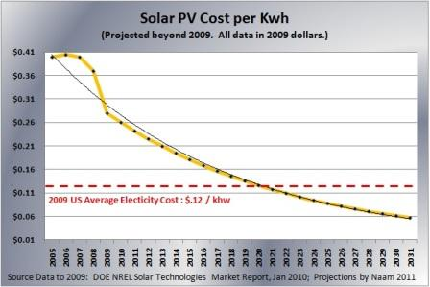

Source: Ramez, Naam. “Smaller, Cheaper, Faster: Does Moore’s Law Apply to Solar Cells?” Scientific American. March 16, 2011.

Annex 7.7: Budget Notes

BUDGET NOTES

Outcome 1

71200 | International Consultants | Work with developing States and SIDS to develop high quality action plans in accordance with ICAO approved guidance that will form the basis for identifying different measures to reduce emissions best suited for the States assisted.
71300 | Local Consultants | Project component coordination and technical oversight by ICAO, monitoring project performance, making available necessary data and tools for smooth progress of the programs and projects.
71400 | Contractual services (companies) | A firm will independently conduct a detailed environmental assessment of the costs and benefits associated with implementing the various feasible measures in developing States and SIDS, documenting transparently the process which will be referenced for future Knowledge Management purposes. RE energy, alternative fuels, carrier operational measures and navigational (NAV) measures with costs and benefits.
71600 | Travel | Travel costs associated with dissemination workshop.
72400 | Commun & Audio Visual Equip | Costs associated with dissemination workshop.
74200 | Audio visual & Print Prod Costs | Costs associated with dissemination workshop.
Outcome 2
71200 | International Consultants | Policy recommendations and organizational structure to incorporate environmental policy making in the developing States regulatory framework with costs of implementation. Social, environmental and pecuniary benefits of policy making relating to aviation environment. Policy guidance will form the basis for future action in the area of environmental policy relating to aviation.  Policy recommendations on financing mechanisms for implementing environmental measures and structural reforms in the developing States including private sector partnership guidelines, PPAs and model land transfers for environmental projects from stakeholders like airports and compatibility with ongoing work in the UNFCCC process. Guidance will accelerate the financing processes to bring in capital for environmental projects and actual policy making in States.  Policy recommendations on generation and offloading of vetted offsets (creation of offset market potential) from the environmental measures implemented in the developing States and compatibility with CDM process.  Policy recommendations on making land available for use of biofuel with focus on impacts on food security. Will address concerns on land use by regions and facilitate policy making.  Technical and legal policy recommendations on cross border mechanisms to bring about NAV improvements in air space including ASBU. Facilitate cross border cooperation in bringing about NAV improvements.
71300 | Local Consultants | Project component coordination and technical oversight by ICAO, monitoring project performance, making available necessary data and tools for smooth progress of the programs and projects.
74200 | Audio visual & Print Prod Costs | Printing of technical guidance materials
Outcome 3

71200 | International Consultants | Technical platform (TP) will bring together all technical information, standards, tools, latest developments, information on indicative costs, benefits, training material, vendor database in a SharePoint like portable accessible anywhere by States. This electronic forum will provide the technical resources to developing States to carry out and implement measures to reduce emissions from aviation by significantly reducing their time, costs and other overheads to collate information.
71300 | Local Consultants | Project component coordination and technical oversight by ICAO, monitoring project performance, making available necessary data and tools for smooth progress of the programs and projects.
71600 | Travel | Travel associated with dissemination workshop
72400 | Commun & Audio Visual Equip | Costs associated with dissemination workshop
74200 | Audio visual & Print Prod Costs | Costs associated with dissemination workshop
Outcome 4

71300 | Local Consultants | Project component coordination and technical oversight by ICAO, monitoring project performance, making available necessary data and tools for smooth progress of the programs and projects.
71600 | Travel | Travel associated with technical oversight of demonstration project
72100 | Contractual services (companies) | Turnkey contract for demonstration project with solar PV. Please refer to Annex 7.9 for Terms of Reference.
Management

71200 | International Consultants | Consultancy for final evaluation
71400 | Contractual Services (Individual) | Project coordination and management
74100 | Professional Services | Audits

Annex 7.8: Co-financing letter

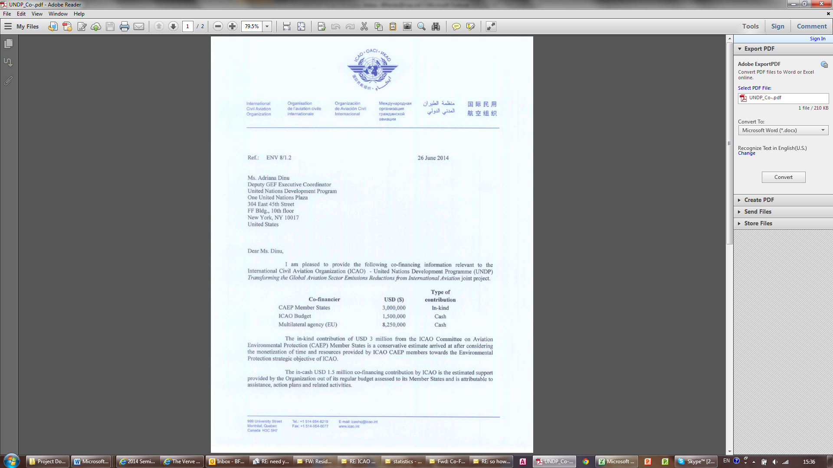



Annex 7.9: Terms of Reference (ToRs) Solar Panels and Project Manager

ToRs Solar Panels
The provisional terms of reference that will be used for the RFP from Vendors are indicated below .
Based on site assessment of the airport, the electrical systems of the airport to be connected to the solar PV systems are proposed for the following land areas –
- Land area (Ground mounted) – 4,550 m²
- Land Area (Roof top mounted) – Flat – 2,300 to 3,300 m²
- Land Area (Roof top mounted) – Sloping – 1,200 to 1,600 m²
For each of the above three specifications, the following specifications are to be provided:

Physical parameters
Module dimensions (mm)
Module weight (kg.)
Cells in each solar panel cells
Number of solar panels
Panel Wattage (W)
System size (KW)
Frame material
Glass type with (mm)
Lifetime (years)

For the indicated physical parameters the following needs to be furnished:
Temperature coefficients and Parameters |  | Electrical Characteristics
Nominal Operating Cell Temperature (NOCT) (°C) |  | Rated Maximum Power Pmax (W)
Temperature Coefficient of Pmax (%/°C) |  | Open-Circuit Voltage Voc (V)
Temperature Coefficient of Voc (%/°C) |  | Short Circuit Current Isc (A)
Temperature Coefficient of Isc (%/°C) |  | Module Efficiency (%)
Operating Temperature (°C) |  | Maximum Power Point Voltage Vmpp (V)
Maximum System Voltage (V) |  | Maximum Power Point Current Impp (A)
Limiting Reverse Current (A)
Maximum Series Fuse Rating (A)
Power Range (W)

The costs for the above indicated technical specifications is to be provided for the three mentioned land availability scenarios.
The cost information to be provided are as follows in USD:
- Turnkey costs: Include breakup of the total costs for each component (material, transport, labour, other Installation costs, taxes etc., up to and inclusive of the stage of Commissioning of the Project).
- Annual maintenance and service costs as a contractual service provided by the Vendor.
- Costs of Warranty and the Warranty period for different options.
Indicate key features of the proposal, specifically:

- Material used for the solar cells
- Use of textured glass and anti- reflective coating
- Load withstanding capability
- Corrosion tolerance levels of the solar panel frames
- Conformity to the industry standards testing along with the Standard Name – Certifying conformity with operations in different climates and electric safety.

— — — — — — — —
ToRs Project Manager*
Expected Duties and responsibilities:
Operational project management , under the supervision of the ICAO Deputy Director Environment, in accordance with the Project Document, UNDP, and ICAO guidelines and procedures for UN Agency executed projects, including:
- General coordination, management of project implementation;
- Ensuring the delivery of project results and leading the implementation process for the 4 project components;
- Management of the procurement and the project budget under the supervision of DD/ENV to ensure timely involvement of local and international experts, organization of training and public outreach, purchase of required equipment etc., in accordance with ICAO rules and procedures;
- Submission of quarterly progress reports and provision of inputs for the Annual Project Implementation Reviews to the PSC, ICAO and the UNDP, in accordance with the section “Monitoring Framework and Evaluation” of the Project Document;
- Ensuring effective dissemination of, and access to, information on project activities and results, including regular participation in relevant selected networks;
- Oversight and coordination of the contracts of the international and local consultants working for the project; and
- Ensuring otherwise successful completion of the project in accordance with the stated outcomes and performance indicators summarized in the project’s results Framework in paragraph 3.1 and within the planned schedule and budget.

Expected Qualifications:
- Advanced university degree and at least 5 years of professional experience, or university degree with 10 years of professional experience in the specific areas the project is dealing with;
- Experience in managing or participating in projects of similar complexity and nature;
- Demonstrated experience and success in the engagement of, and working with, the private sector and Governments, creating partnerships for activities of common interest;
- Good analytical and problem-solving skills and the related ability to adaptively manage with prompt action on the conclusion and recommendations coming out from the project’s regular monitoring and
self-assessment activities as well as from periodic evaluations;
- Ability and demonstrated success to work in a team, to effectively organize it, and to motivate its members and other project counterparts to effectively work toward the project’s objectives and expected outcomes;
- Good communication skills and competence in handling project’s external relations at all levels; and
- Familiarity and prior experience with UNDP and GEF requirements and procedures are considered an asset.
------------------------------------------------------------------------------------------

*The ToRs for the Project Manager could be refined for the recruitment phase.
The ToRs for the additional consultants will be developed and provided after the inception workshop.

8. SIGNATURE PAGE
Country:

UNDAF Outcome (s)/Indicator (s):
CPAP Outcome (s)/Indicator (s):

CPAP Output (s)/Indicator (s):

Executing Entity/Implementing Partner
Implementing entity/Responsible Partner

Total resources required ________________
Total allocated resources: ________________
- Regular ________________
- Other:
  - GEF ________________
  - Government ________________
  - In-kind ________________
  - Other ________________

In-kind contributions ________________ ________________

Programme Period: _____________

Atlas Award ID: ______________
Project ID: ______________
PIMS # ______________

Start date: ______________
End Date ______________

Management Arrangements ______________
PAC Meeting Date ______________

Agreed by (Government):

NAME SIGNATURE Date/Month/Year

Agreed by (Executing Entity/Implementing Partner):

NAME SIGNATURE Date/Month/Year

Agreed by (UNDP):

NAME SIGNATURE Date/Month/Year

The FESG analyses include estimates of: engine and aircraft emissions, populations around the world living near airports affected by aircraft noise and local air quality issues, and the contribution of aviation to global GHG emissions and climate change.
[1] http://www.icao.int/Newsroom/Pages/ICAO-to-assist-Indonesia-with-new-aviation-emissions-reduction-initiatives.aspx
The two workshops will disseminate information as indicated in outputs 1.2, 3.2 and 4.3 and will be organized in regions with SIDS, see note 1. Dissemination will also occur in regularly scheduled ICAO event to ensure global outreach.
The two workshops will disseminate information from outputs 1.2, 3.2 and 4.3 and will be organized in regions with SIDS.
CASSOS Member States : Barbados, Guyana, Haiti, Jamaica, the OECS, Suriname, Trinidad and Tobago
Estimation based on a GPU used for a Boeing 787 Dreamliner that, depending on its configuration, can carry about 300 passengers - variants seat configuration 210 to 335 passengers.
Two workshops will disseminate information from outputs 1.2, 3.2 and 4.3 and will be organized in regions with SIDS, in addition to regularly scheduled ICAO events in other regions.
. The project Manager report to the DD/ENV - see more information in section 4 Management Arrangements
Summary table should include all financing of all kinds: GEF financing, co-financing, cash, in-kind, etc.
ICAO developed the Rules of Thumb to assist National Focal Points to estimate the benefits associated with a specific measure. The Rules of Thumb are available in Doc 9988

